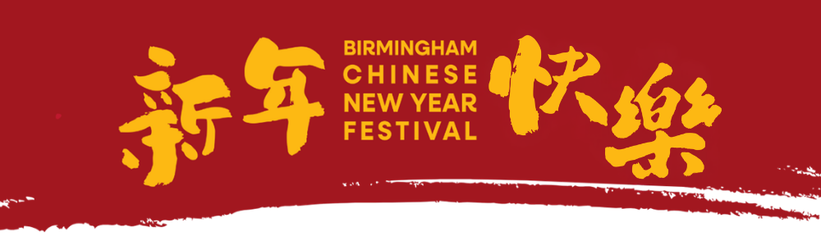

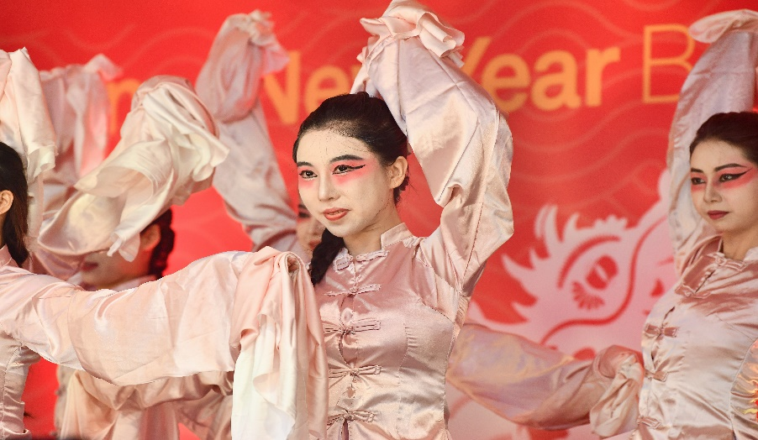
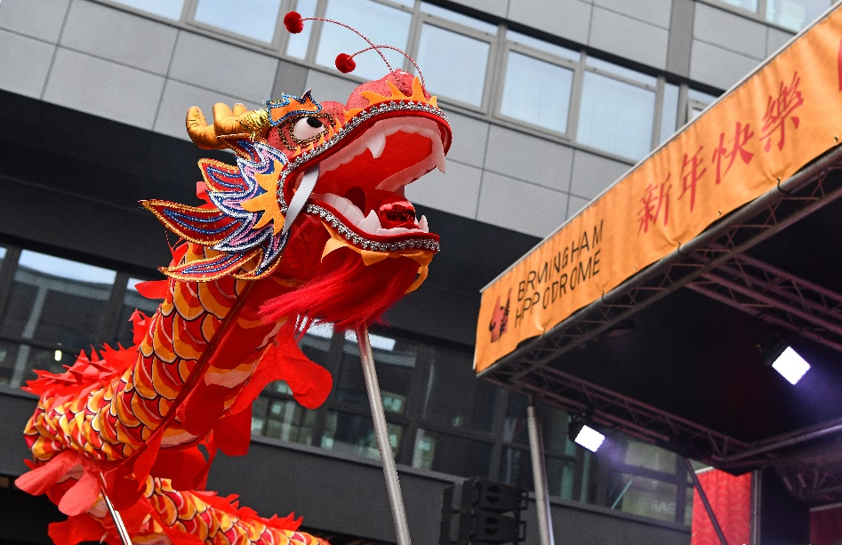
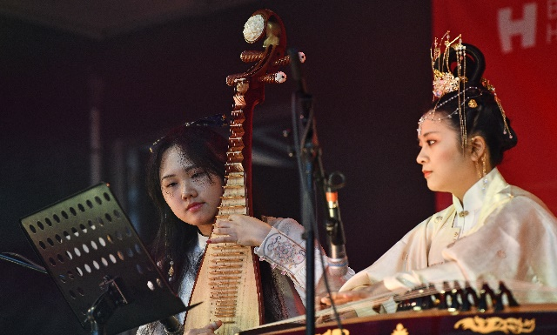
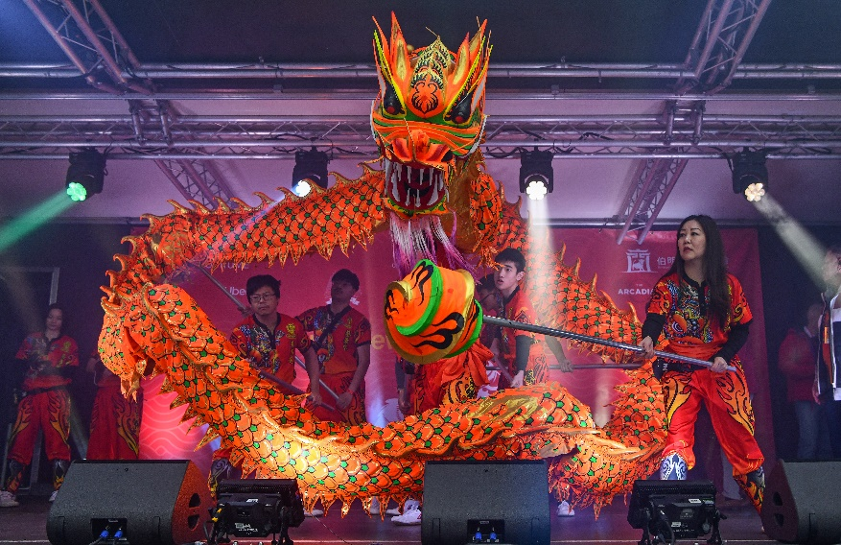
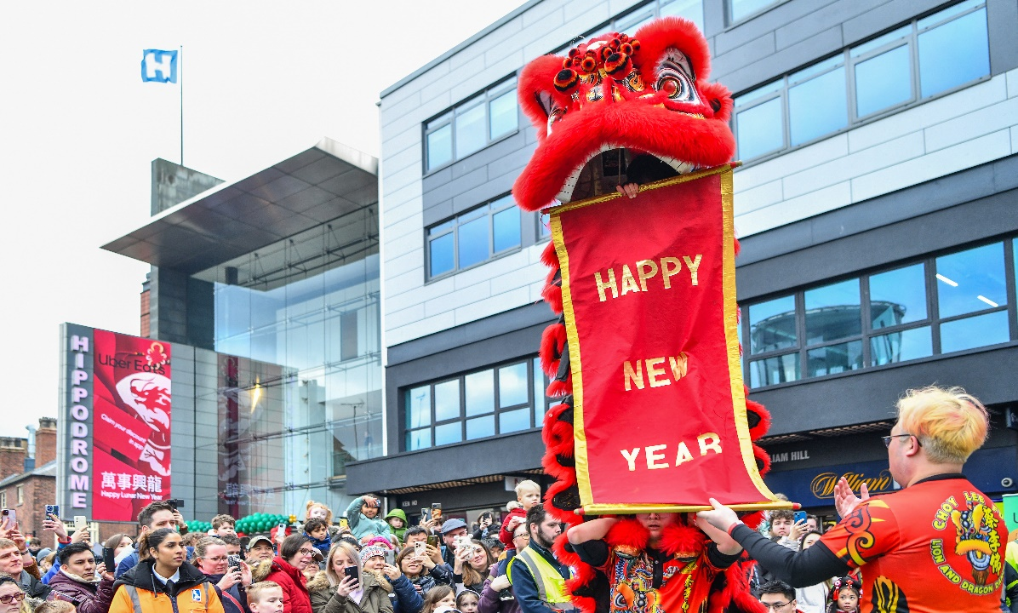
Access Pack for Birmingham Chinese New Year Festival
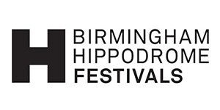
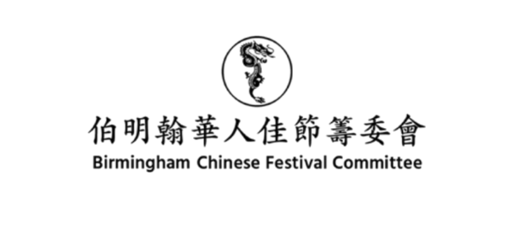

What is Chinese New Year?
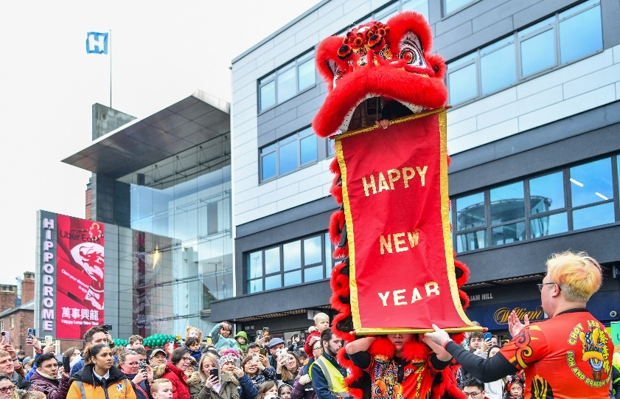

Chinese New Year is the main Chinese Festival of the Year.


Chinese New Year is worked out according to the first day of the Chinese lunar calendar.

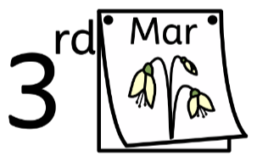
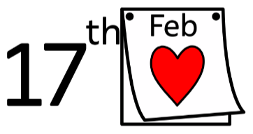

The celebrations fall somewhere between 17th February and 3rd March.

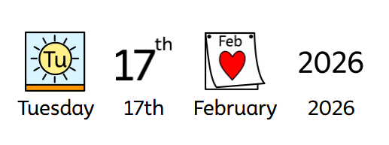
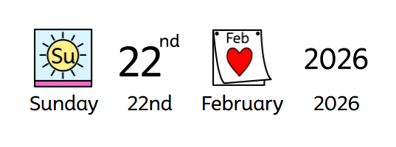

Birmingham Chinese New Year Festival 2026 is being celebrated from Tuesday 17th February 2026 – Sunday 22nd February 2026.
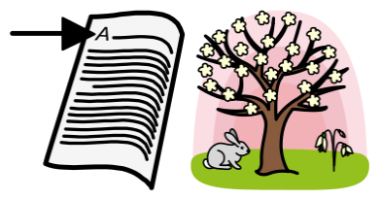
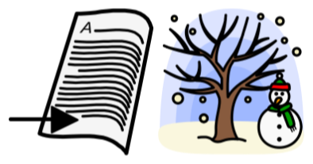

Chinese New Year marks the end of winter and the beginning of spring.
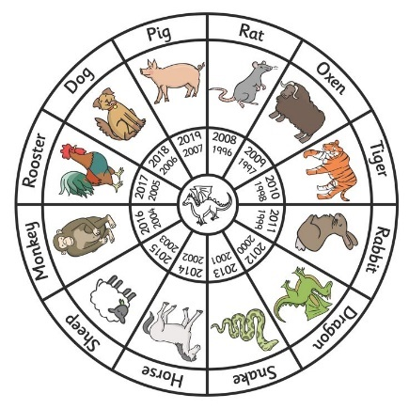

In Chinese tradition, each year Is represented by one of 12 Zodiac animals.


Chinese New Year 2026 marks the year of the horse.

What is Birmingham Chinese New Year Festival?
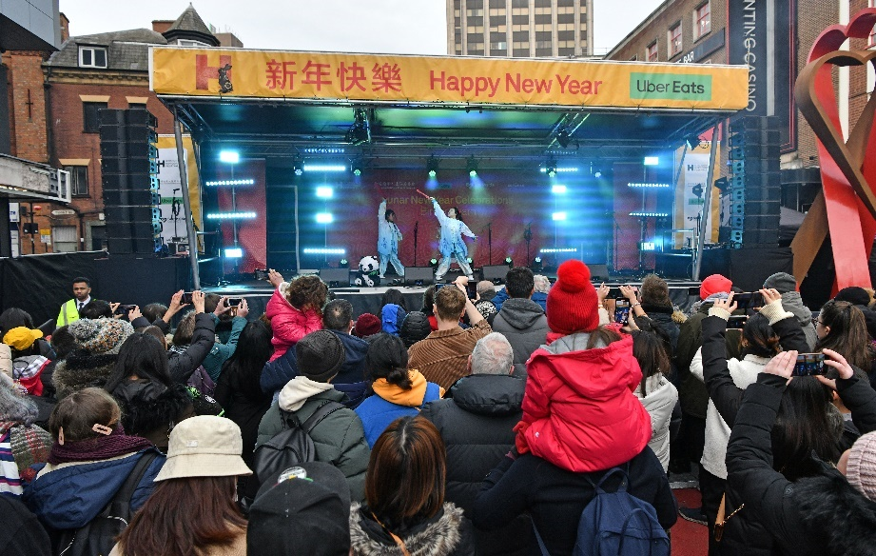

There will be a festival to celebrate Chinese New Year in Birmingham City Centre. On Sunday 22nd February.

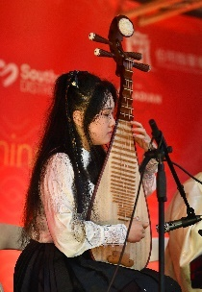
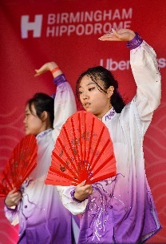
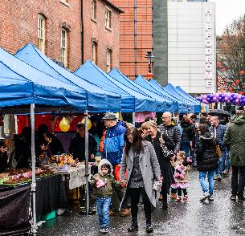
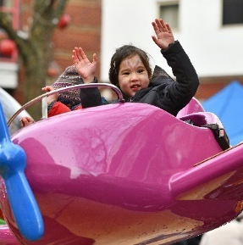

There will be music, dancing, markets and fairground rides

Here are some pictures of where the festival will take place and what you will be able to watch.

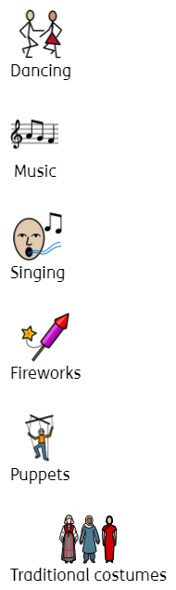
The Main Stage – Ladywell Walk
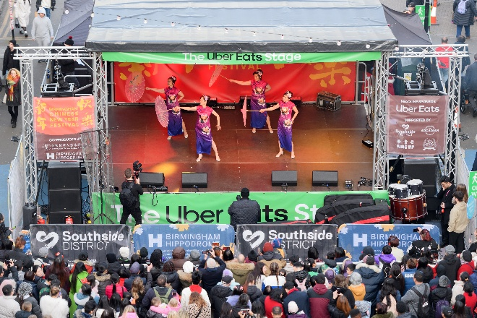
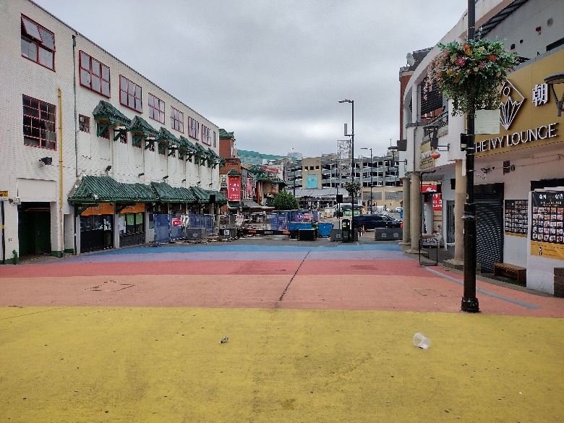

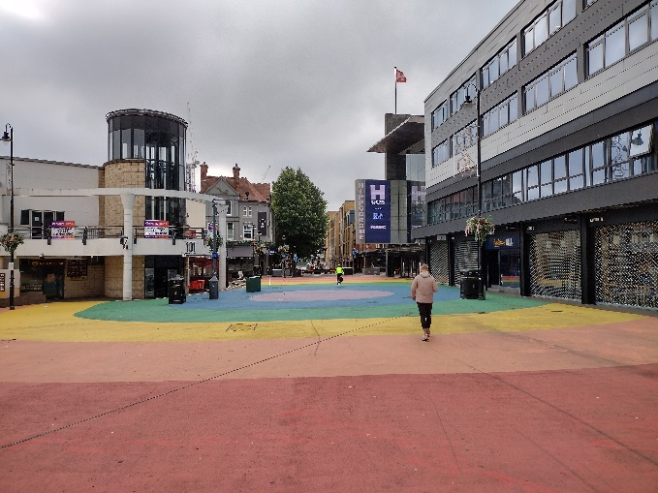
Hurst Street and Inge Street
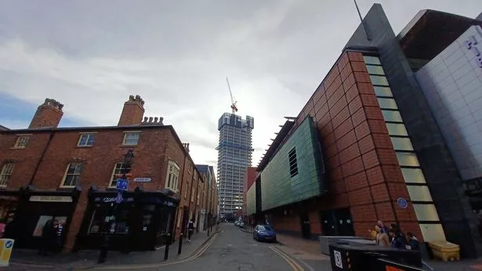
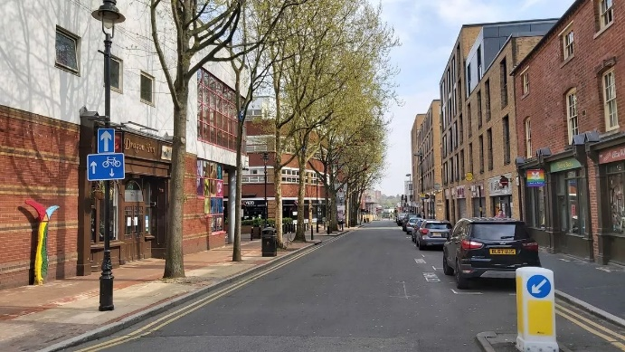
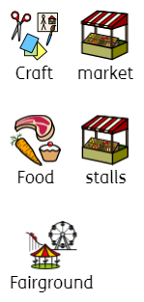

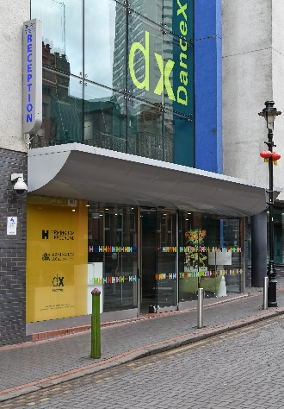
Inside Birmingham Hippodrome
Please use the Thorp Street entrance.

Inside Birmingham Hippodrome you can see…
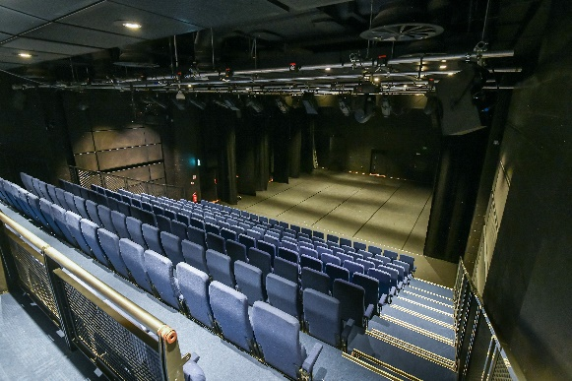
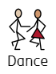

in the

Patrick Studio

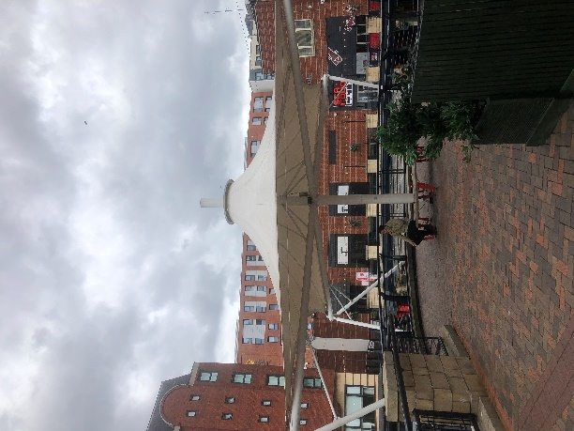
The Arcadian
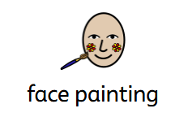

Under the

Umbrella in the Arcadian

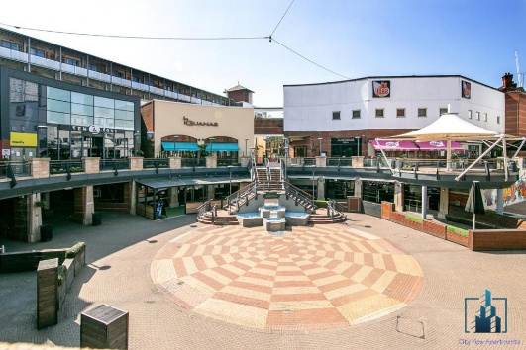
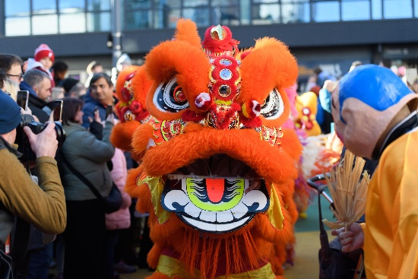

In the

Lion dancing Arcadian

Walkabout
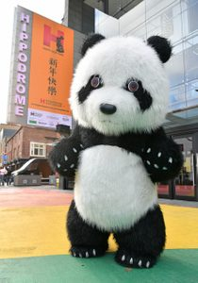
Pom Pom the Panda will be walking around the festival at certain times of the day!

Access at Birmingham Chinese New Year Festival
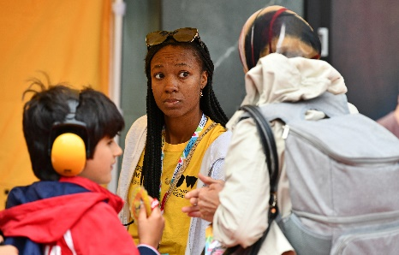
Access Offer
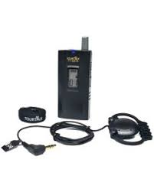



ACCESS HUB – LOCATED AT THE FRONT OF BIRMINGHAM HIPPODROME - 12PM – 6PM
Meet our access hosts, find out about the festival, borrow ear defenders, fidget toys & audio description headsets.

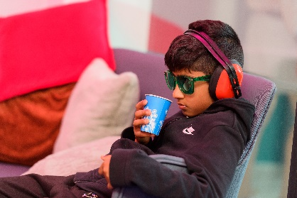
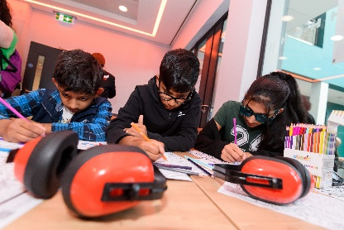

CHILL OUT ZONE – ARTISTS LOUNGE – BIRMINGHAM HIPPODROME - 12PM – 6PM
Take a break from the busy festival environment in our chill out zone.

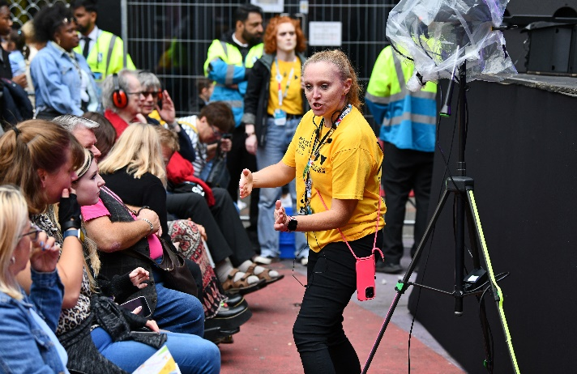

ACCESSIBLE VIEWING POINT – IN FRONT OF THE MAIN FESTIVAL STAGE
Providing space for those that need it with a great view of the action – this is very close to the stage so expect it to be loud - the viewing area will be closed before and for the duration of any pyrotechnic effects for safety purposes.

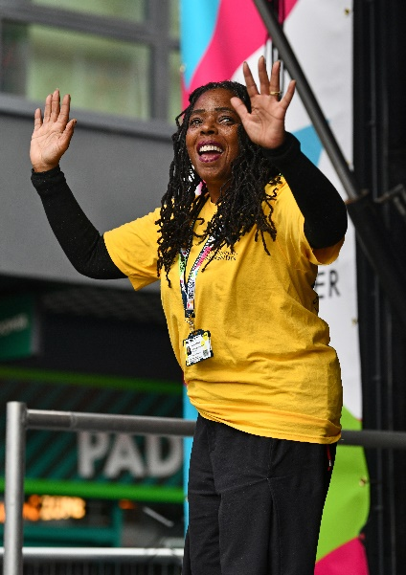

BSL BRITISH SIGN LANGUAGE INTERPRETATION
THE MAIN FESTIVAL STAGE - 12PM – 6PM
Throughout the day interpreters will be working alongside our hosts to offer BSL provision for the stage.

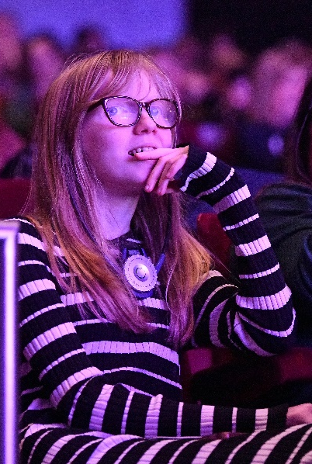

AUDIO DESCRIPTION TRACKS
THE MAIN FESTIVAL STAGE – VARIOUS ACTS BETWEEN 12PM – 6PM
Audio Description tracks will be available via a QR code at our access hub. Please ensure you have a device and headphones to listen to the tracks. If you need any assistance with accessing this, just ask our access hosts.


Sensory and Emotional Highlights

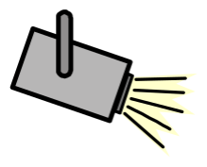

It might be quite cold. So please wrap up.
The music and talking on the microphones might be quite loud.
There will be stage lights used throughout the day. No strobe lights will be used during the performances.
It might get very busy.
Wheelchair Access
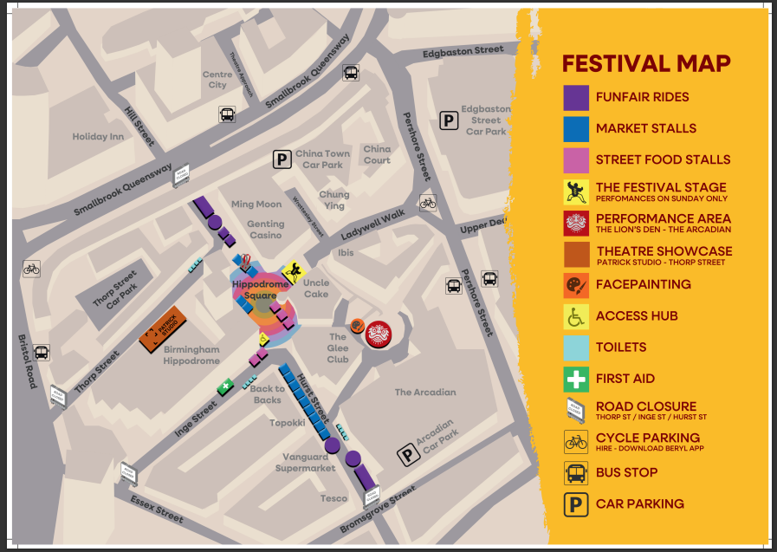
Wheelchair Access – There will be a one way system in operation on Ladywell Walk. You will not be able to enter the festival site from behind the Main Stage. These are the wheelchair routes available:
- From New Street Station – Travel down Hill Street, cross the road at Smallbrook Queensway and then continue down Hurst Street.

- From Edgbaston Street Car Park – Travel along Pershore Street Towards the Arcadian. Go through the entrance of the Arcadian. Continue to travel through the Arcadian. As you add the central park of The Arcadian, travel towards the car park and on the left will be access to the lift.

- From Bromsgrove Street – Travel up Thorp Street.

- From Arcadian Car Park – Park on level 2 (Hippodrome level), there are lots of disabled parking spaces. Once you have exited the car park you will arrive in The Arcadian. Keep going straight and you will arrive at the festival site.

