A Place Between Mass & Echoes

By

Inviktus Collective

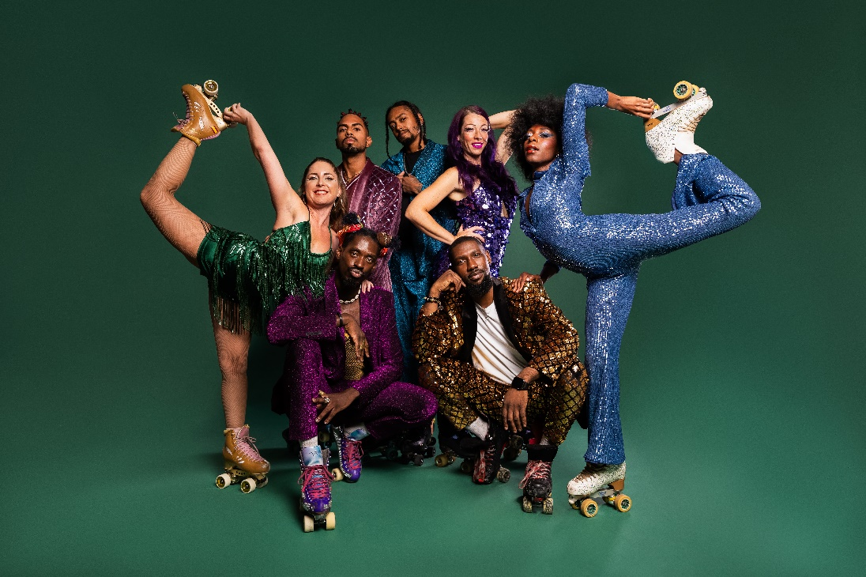

Saturday 23rd and Sunday 24th August

At 12PM, 2PM, and 4.30PM

|  |  |  |
| --- | --- | --- |
|  | | Saturday 23rd and Sunday 24th August  Performances are at 12PM, 2PM, and 4.30PM.  Each performance is 30 mins. |
| Who is it for?   | |  |
| Where is it?   | Bullring Lower Mall West (outside M&S)   | |
| About the performance   | |  |
|  | | Audio Description - Screen Machine  Live Audio Description at 12pm, 2pm, and 4.30pm.  and  Accessible Viewing Point in front of HMV and Boots. |

Find out more

[A Place Between Mass & Echoes - Without Walls](https://withoutwalls.uk.com/programme/a-place-between/#:~:text=A%20Place%20Between%20Mass%20%26%20Echoes%20is%20a,moves%2C%20high%20energy%20tricks%2C%20naturalistic%20movements%20and%20rest.)

Contact us

[Charlotteboyer@birminghamhippodrome.com](mailto:Charlotteboyer@birminghamhippodrome.com)

[Ahlaammoledina@birminghamhippodrome.com](mailto:Ahlaammoledina@birminghamhippodrome.com)