Dhol & Dance
by

Eternal Taal



Sunday 24th August
2.45pm and 5.15pm
Time   | 2.45pm and 5.15pm  Each performance is 30 mins.  But you can come and go as you please.
Who is it for?   | Everyone!
Where is it?   | 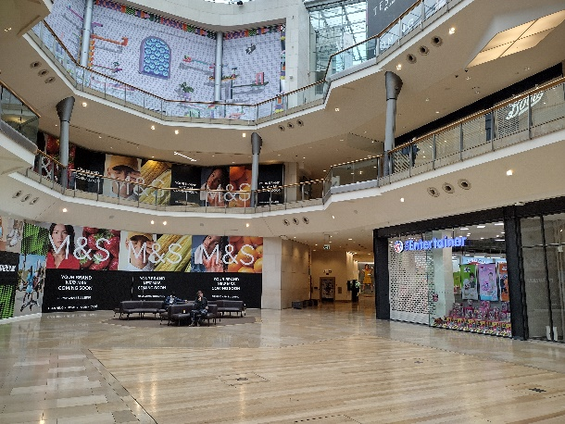  Lower Mall West – Outside M&S
Access   | There will be an Accessible Viewing Point on the middle floor, in front of HMV and Boots.
Content warnings   |   The experience contains loud music.    It might get busy.
  Main themes |   Interactive experience      Dancing    Music

Contact us
charlotteboyer@briminghamhippodrome.com
ahlaammoledina@birminghamhippodrome.com

