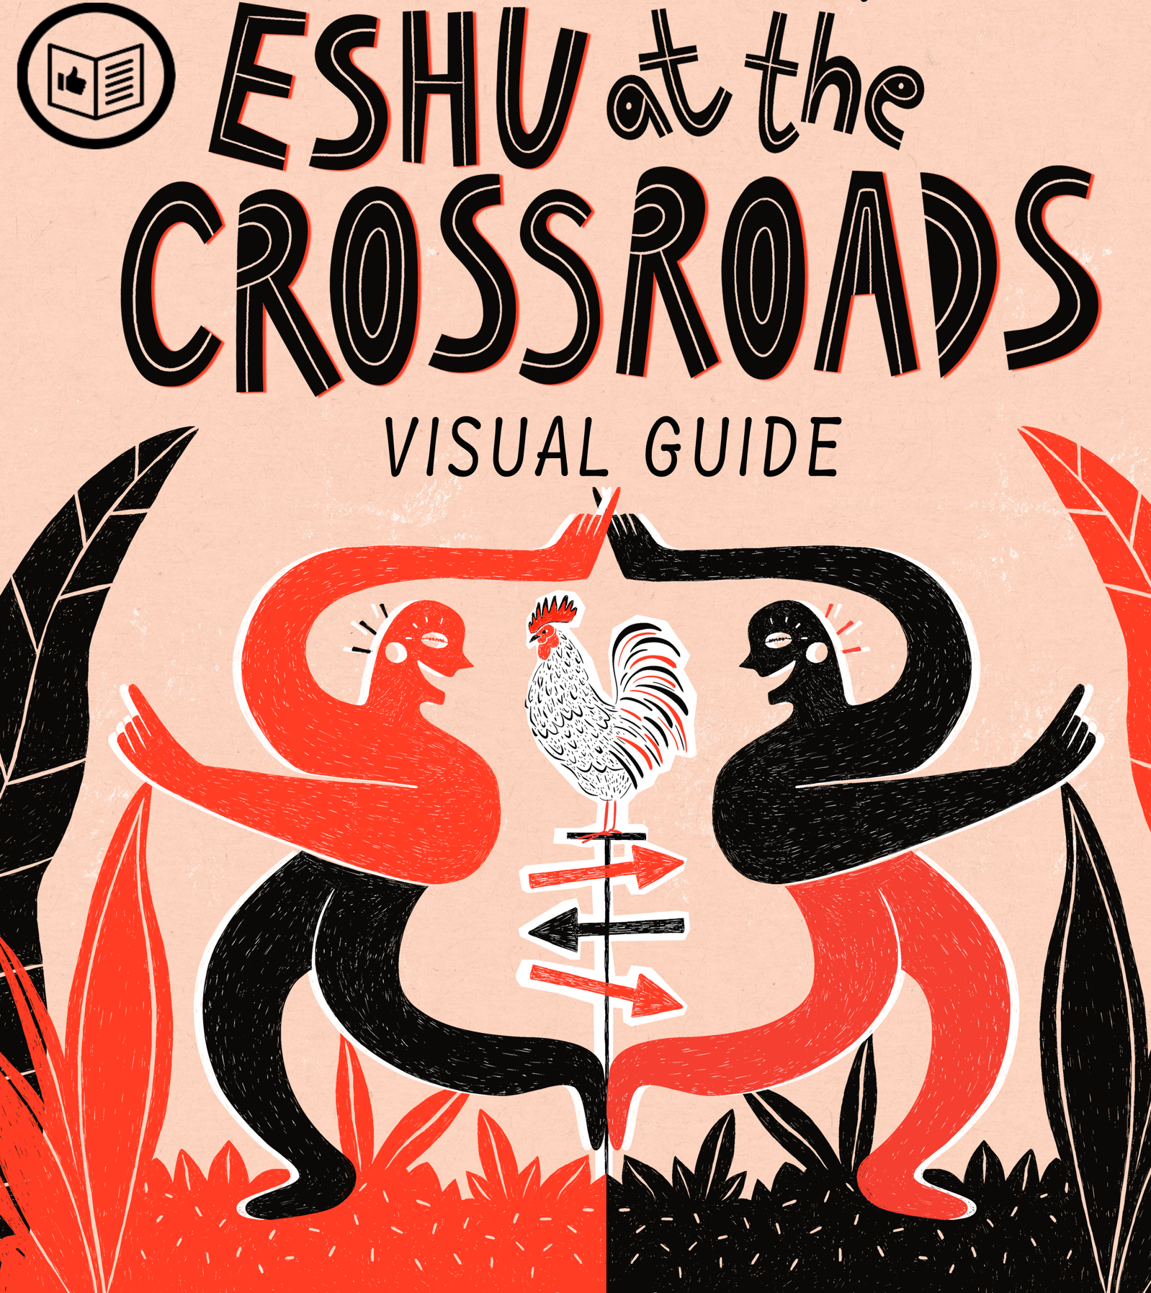

Eshu at the Crossroads is a 30-minute outdoor show with dance and puppetry. It has been created by Theatre-Rites and Afro Cuban choreographer Miguel Altunaga.

The show has been inspired by Miguel’s Cuban heritage.

This visual guide will help prepare you for your visit and to help you become familiar with the surroundings and situation. Please use these notes as little or as much as you need to.

We hope you have a lovely time and enjoy the show.


What to Expect:

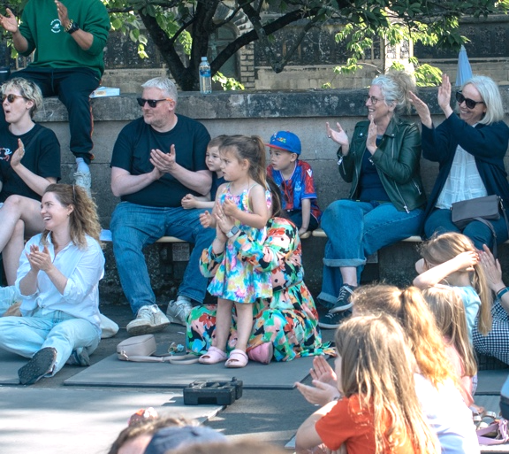 |  | Who is it for?  This show is for everyone aged 4+
 |  | Dates and Times:  Monday 25th August  [times tbc]
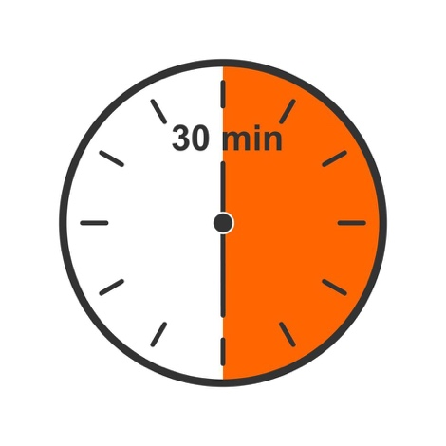 |  | Length of show:  30 minutes
   |  | Access:  Xxxx

 |  | Access Viewing Area for:  - Wheelchair users.  - Anyone who needs a seat.  - Companions.  Anyone who needs it for access reasons.
 |  | Music and Sound:  The music is played through speakers.  Sometimes in the show, the music might get louder and sometimes it might get quieter. The mood of the music changes to reflect what is happening on stage.
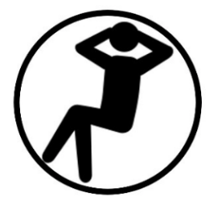 |  | You are welcome to:  Move around – just not on stage  Make noise  Join and leave at any time

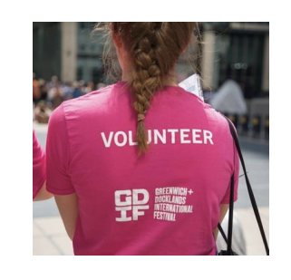 |  | Volunteers  Friendly volunteers from the Birmingham Weekender will be there to help.  They will be wearing xxxx.
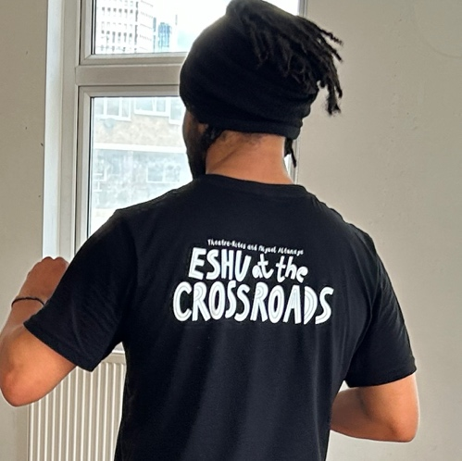 |  | There will also be members of the Theatre-Rites Team around to help.  They will be wearing black t-shirts with Eshu At The Crossroads printed on the back.

Meet The Cast

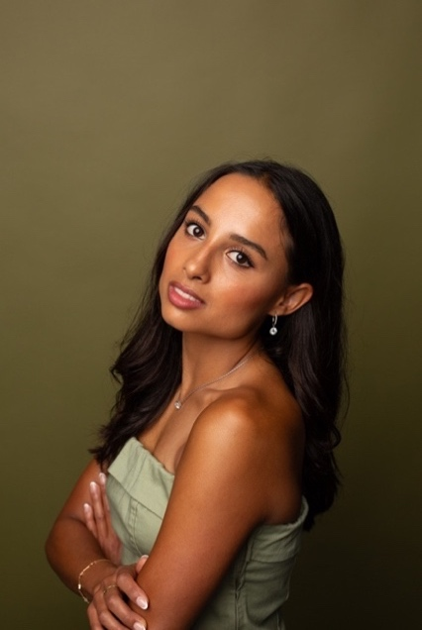  Tanisha Addicott  Dancer |  | 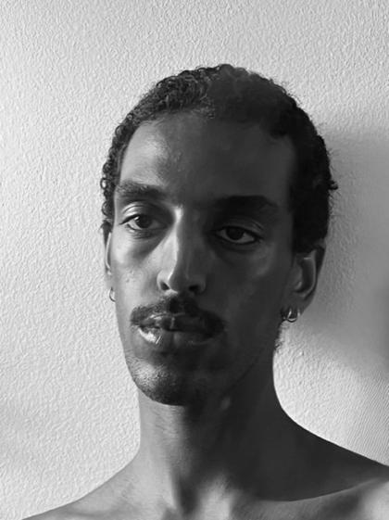  Natnael Dawit  Dancer
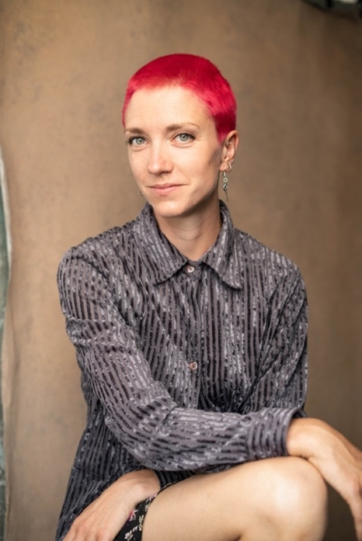  Edie Edmundson  Puppeteer |  | 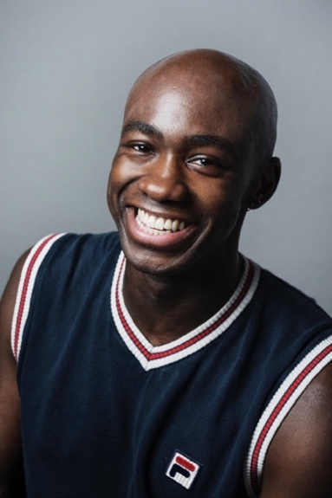  Alecsander Javier Nilsson  Dancer

There are 3 performers in the show. One puppeteer and two dancers.

You will see one of the following cast versions:

Edie, Natnael, Alecsander
Edie, Natnael, Tanisha
Edie, Tanisha, Alecsander

Characters in the Show

There are several different characters that the cast play in the show.

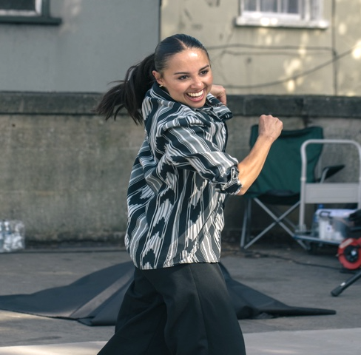 |  | The Traveller: the main character, performed by one of the dancers. They are dressed in black trousers, black t-shirt and a grey, white and black patterned shirt.
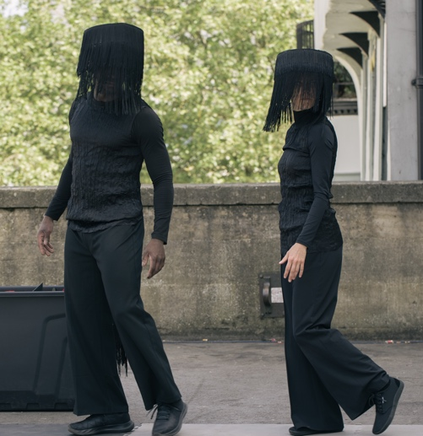 |  | Masked Performers: two performers are dressed in black and wear black fringed masks. They are invisible to the Traveller.
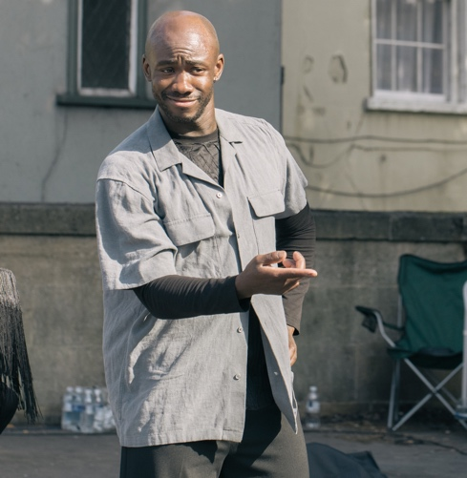 |  | Human: one fringed performer becomes ‘human’ and we see them remove their mask and appear on stage in a grey linen shirt.
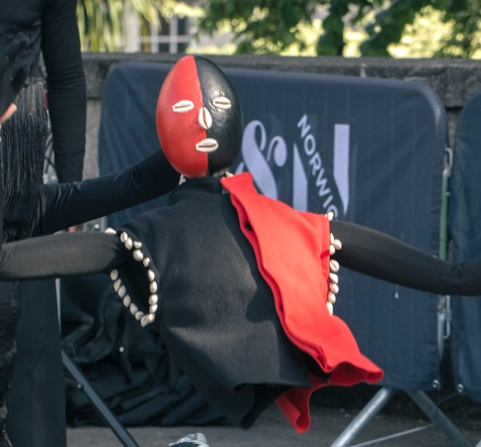 |  | Eshu: a spirit from Yoruba culture who appears in different forms – as a red and black jacket, a red and black half body puppet and a red and black head.

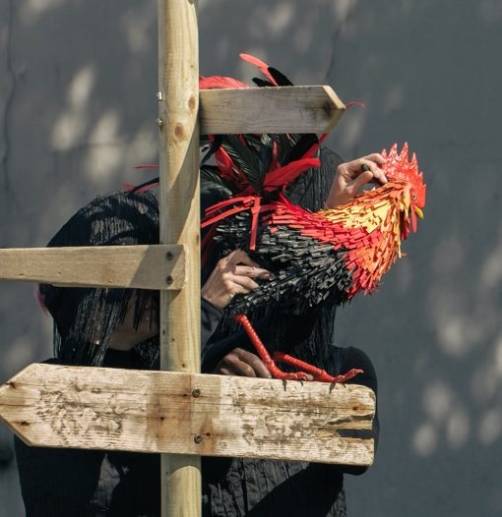 |  | Rooster: appears as a life-sized colourful puppet in an early scene.
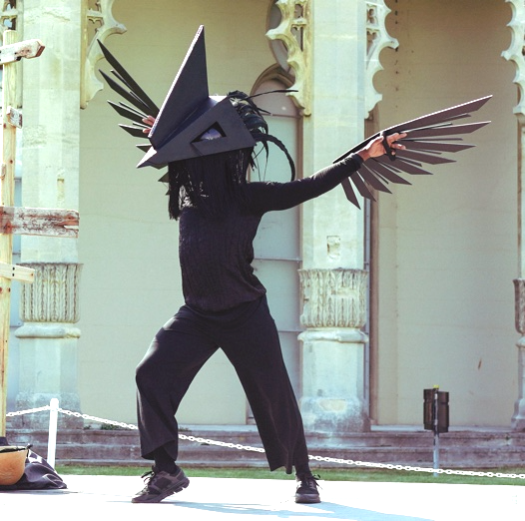 |  | The Spirit of the Rooster: appears wearing a large black mask and black wings.
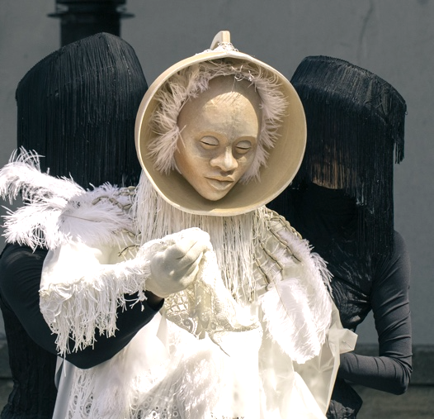 |  | Ochanla: This is a puppet who is an old and wise majestic figure dressed in white lace and fringing.

If you would like more detailed information about what happens during the performance, you will find it on the following 4 pages.

About Eshu At The Crossroads:

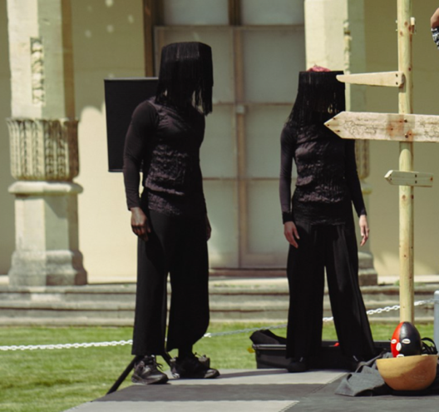 | At the start of the show, we see a wooden crossroads sign on the stage. Two Masked Performers appear and set up the space in a ritualised manner.
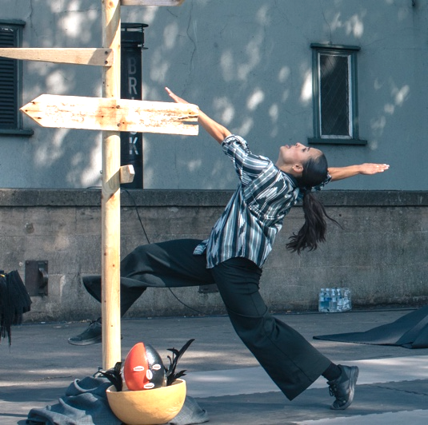 | The Traveller appears. We watch them dance as they reach the crossroads, but they don’t know which way to go.
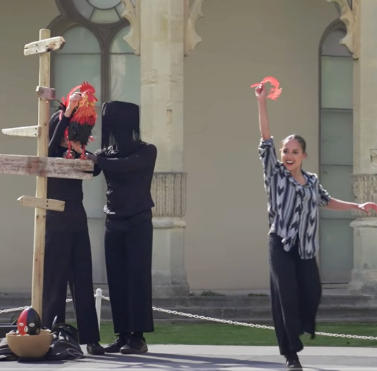 | The Rooster arrives to help but confuses the Traveller even more, and after mocking them and pecking them, the Traveller pulls a red feather from the Rooster’s tail.
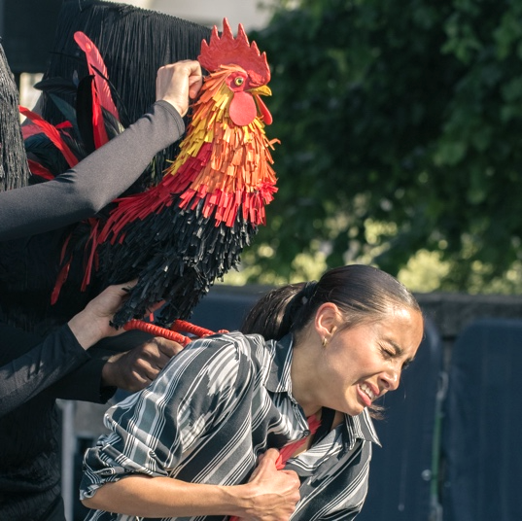 | The Rooster is angry and attacks the Traveller, before leaving the stage. The Traveller feels pleased with themself and dances with the feather.

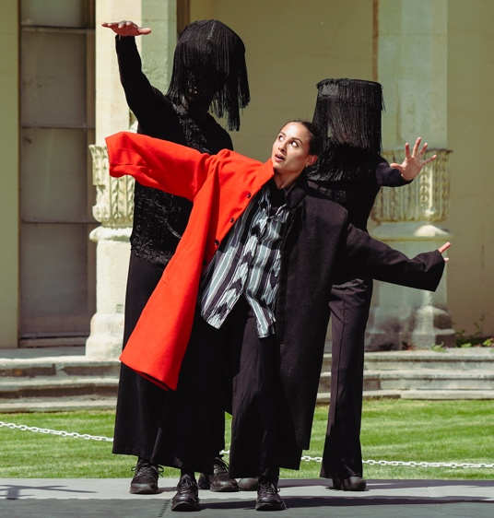 | The Masked Performers return with a version of Eshu, as a black and red coat. The Traveller puts on the coat and they dance in it feeling very smug and cool.
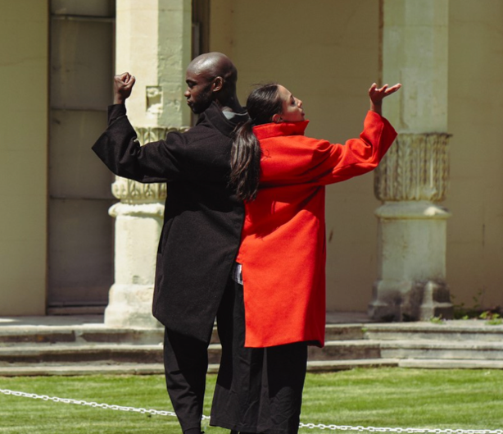 | One of the Masked Performers removes their mask and appears as a human. They admire the coat and slip themself into it so they both wear it. A struggle for ownership and the coat tears in half.
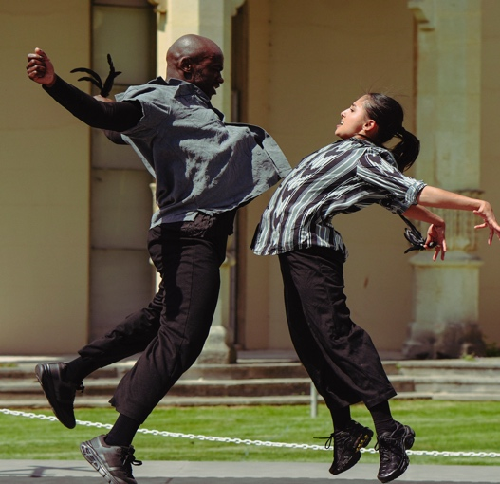 | The other Masked Performer takes them both by the scruff of the neck and removes the coat. They hand them both feathers which starts a fight-off, in dance form.
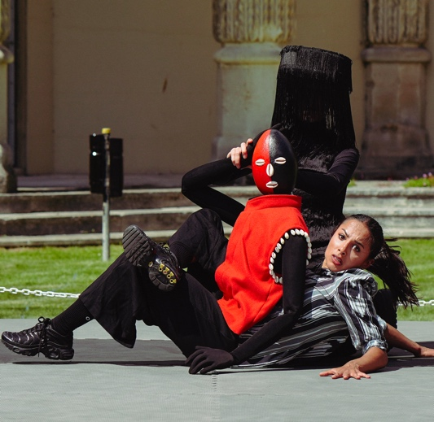 | The Masked Performers return with Eshu as a half body puppet - a red and black top with a head which entwines itself around the Traveller.

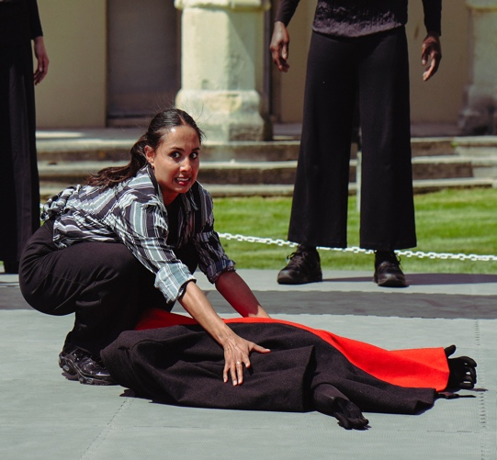 | A competition begins: who is the top and who is the bottom? At first playful the dance soon becomes a fight which ends with the Traveller accidentally killing the spirit of Eshu.
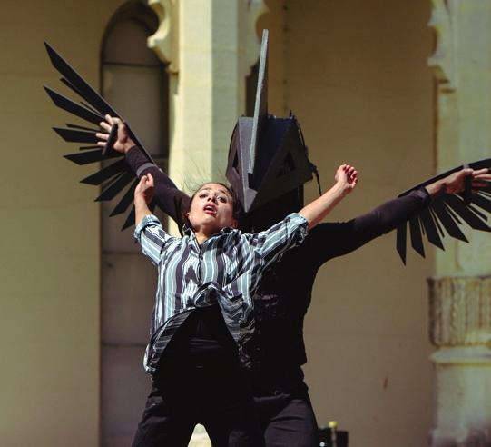 | One of the Masked Performers puts a large black headpiece and black wings onto the other, becoming the spirit of the Rooster. The atmosphere and music become a little sinister. The spirit dances and swirls around the Traveller in a menacing way.
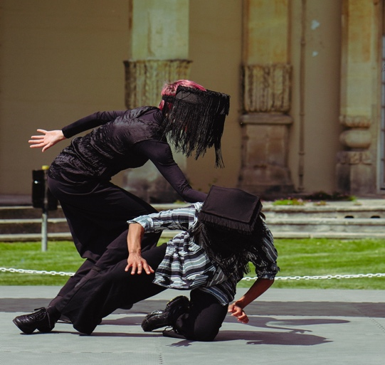 | This dance is concluded when the other Masked Performer places a black fringed mask over the Traveller’s face.  A game of tag ensues.
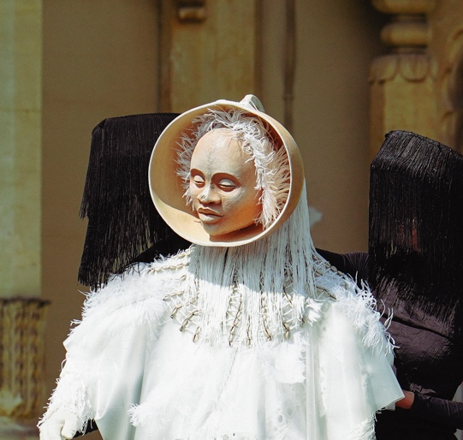 | Ochanla, another spirit, appears on stage. She is an old and wise majestic figure dressed in white lace, manipulated by the two Masked Performers. She lifts her mask to reveal her face.

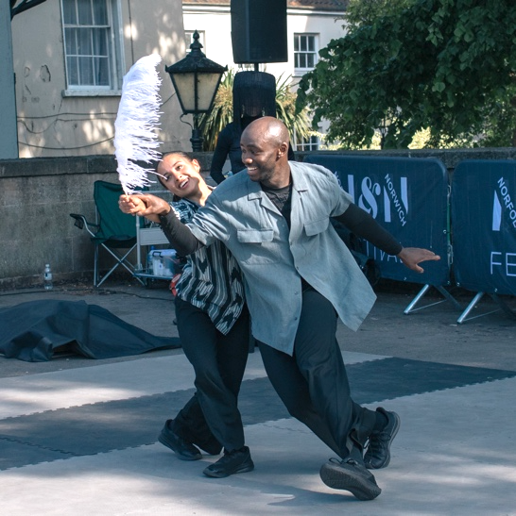 | The Traveller offers the red feather they stole from the Rooster and in exchange, Ochanla gives them a white feather and then retreats. The Traveller dances with the feather in a duet with the Human.
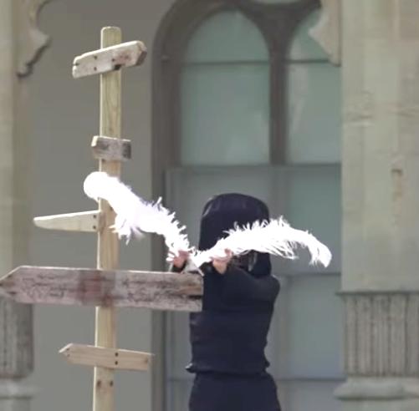 | One of the Masked Performers appears with another white feather and forms the figure of a bird which lands on the signpost and then flies off into the distance.
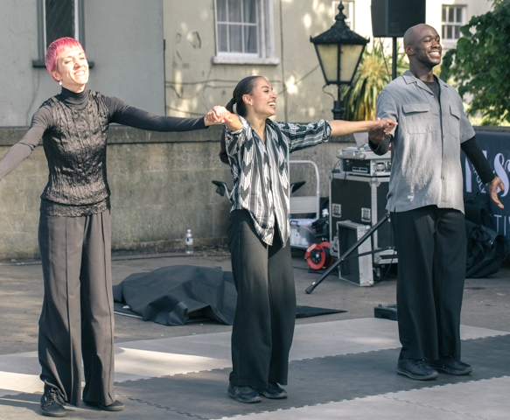 | The show ends and the 3 Performers come onto the stage dancing. The audience claps and the Performers leave the stage.

Creative Team

Director: Sue Buckmaster
Choreographer: Miguel Altunaga
Composer: Domenico Angarano
Puppet Maker: Naomi Oppenheim

Stage Manager: Ruby Sevink Johnston

Find Out More

 | Info about Theatre-Rites:  Award-winning company Theatre-Rites is a field leader in the creation of experimental theatre for children.  Acclaimed nationally and internationally, our touring productions and site responsive works stir the imagination and stimulate thought.  www.theatre-rites.co.uk  Info about Miguel Altunaga:  Miguel is a former dancer at Danza Contemporanea de Cuba, Rambert, Hofesh Shecter Company, Akram Khan Company and Lost Dog. As a choreographer and movement director, he has created pieces for Danza Contemporanea de Cuba, Rambert, Phoenix Dance Theatre and Birmingham Royal Ballet.  www.miguelaltunaga.com
 | Contact:  Email: xxxx  Call or text: xxxx



Eshu at the Crossroads is supported by Without Walls and commissioned by Norfolk & Norwich Festival, Brighton Festival and Birmingham Weekender.

