Go, Grandad, Go!

By

Company DHW

Monday 25th Aug – 12PM, 2PM, & 4.30PM

|  |  |
| --- | --- |
|  | Monday 25th Aug at 12PM, 2PM, & 4.30PM.  Each performance lasts 30 minutes. |
| Who is it for?   | All ages, particularly families. |
| Where is it?   | Lower Mall West – Bullring (outside M&S) |
|  | Audio Description - Screen Machine  Chair Icon Vector Art, Icons, and Graphics for Free DownloadA black and white symbol of a wheelchair  AI-generated content may be incorrect.This performance will be Audio Described and will have an Accessible Viewpoint in front of HMV and Boots.  There will also be BSL-interpretation.  A cartoon of a person's face  AI-generated content may be incorrect.  The piece moderately relies on visuals and speech.  A yellow shirt with black trim  AI-generated content may be incorrect.  Please find an Access Host in a yellow hat for further assistance. |
| Content warnings   | A couple of stick figures playing with a red ball  AI-generated content may be incorrect.  Some parts may be interactive.  A yellow megaphone with many points  AI-generated content may be incorrect.A black and white image of a music note  AI-generated content may be incorrect.  It may be loud at points. |
| Main themes   | A couple of stick figures dancing  AI-generated content may be incorrect.  Dance  A black and white image of a music note  AI-generated content may be incorrect.  Music  A cartoon of a smiling face  AI-generated content may be incorrect.  Comedy |

What will happen during the performance?

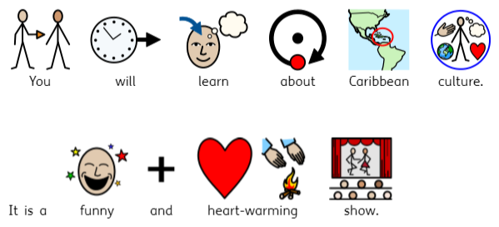

Find out more

<https://withoutwalls.uk.com/programme/gograndad/>

Contact us

[charlotteboyer@briminghamhippodrome.com](mailto:charlotteboyer@briminghamhippodrome.com)

[ahlaammoledina@birminghamhippodrome.com](mailto:ahlaammoledina@birminghamhippodrome.com)