Hydropunk

Artizani



Saturday 23rd August – Monday 25th August

12pm – 6pm
Time   | Saturday 23rd August – Monday 25th August  12 noon - 6pm  But you can come and go as you please.
Who is it for?   | All ages!
Where is it?   | St Martin’s Square - Bullring  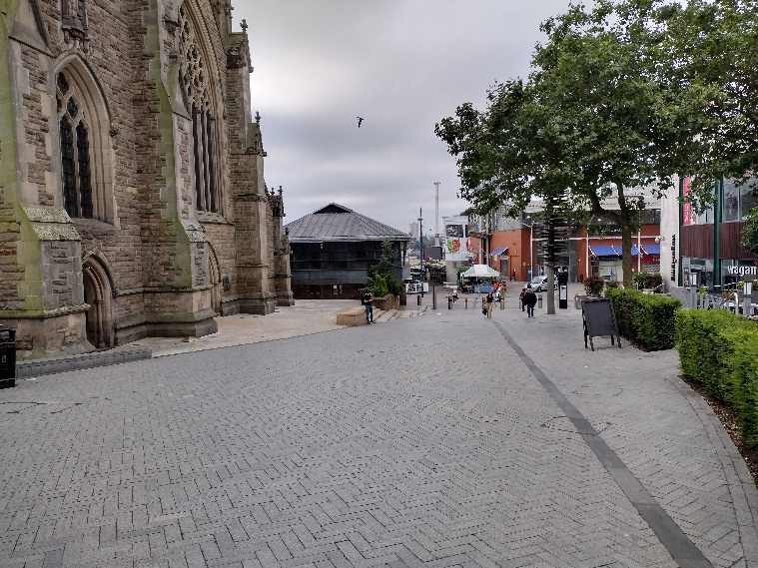
Access   |   This piece does contain text and speech, but it is not needed to understand the story.    There is no music.    The piece moderately relies on visuals.    There will be a queue system in place. From 12pm – 1pm, Access Hosts will be available to support this experience.
Content warnings   |   The piece is interactive.
Main themes   |   Theatre    Environmental    Scientific

What will happen during the performance?
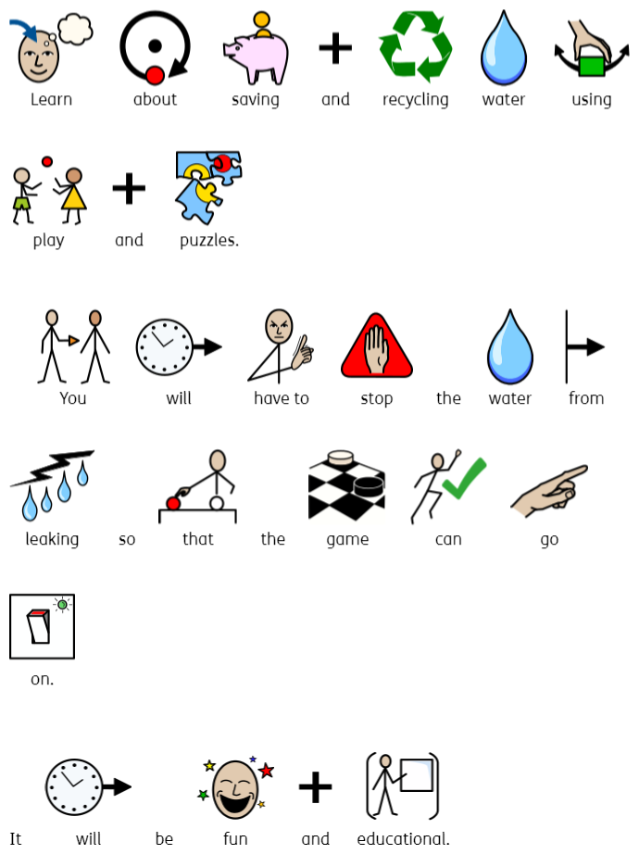
Find out more

https://brightonfestival.org/whats-on/X99-without-walls-hydropunk/

Contact us
charlotteboyer@briminghamhippodrome.com
ahlaammoledina@birminghamhippodrome.com

