L’Atelier

By

Toc De Fusta

Sat 23rd August – Mon 25th Aug

12PM – 6PM

|  |  |
| --- | --- |
|  | Saturday, 23rd August to Monday 25th August.  12 noon - 6pm  But you can come and go as you please. |
| Who is it for?   | Recommended for ages 7+. |
| Where is it?   | Edgbaston Street. |
|  | Access Hosts will be available to support your experience from 12-1pm. |
| Content warnings   | A couple of stick figures playing with a red ball  AI-generated content may be incorrect.  The piece is interactive. |
| Main themes   | A cartoon of people on stage  AI-generated content may be incorrect.  Theatre |

What will happen in this activity?

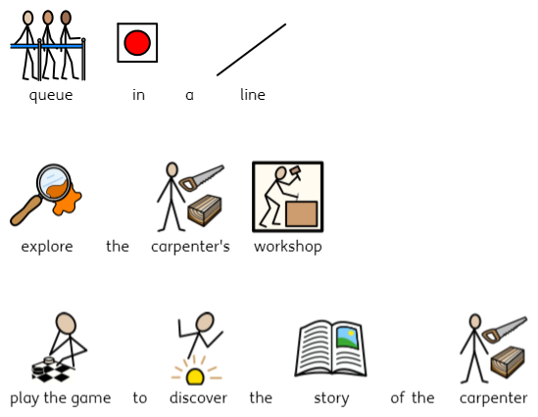

Find out more

<https://tocdefusta.com/en/latelier/>

Contact us

[charlotteboyer@briminghamhippodrome.com](mailto:charlotteboyer@briminghamhippodrome.com)

[ahlaammoledina@birminghamhippodrome.com](mailto:ahlaammoledina@birminghamhippodrome.com)