Flashmobs
by

Marshon Dance Company

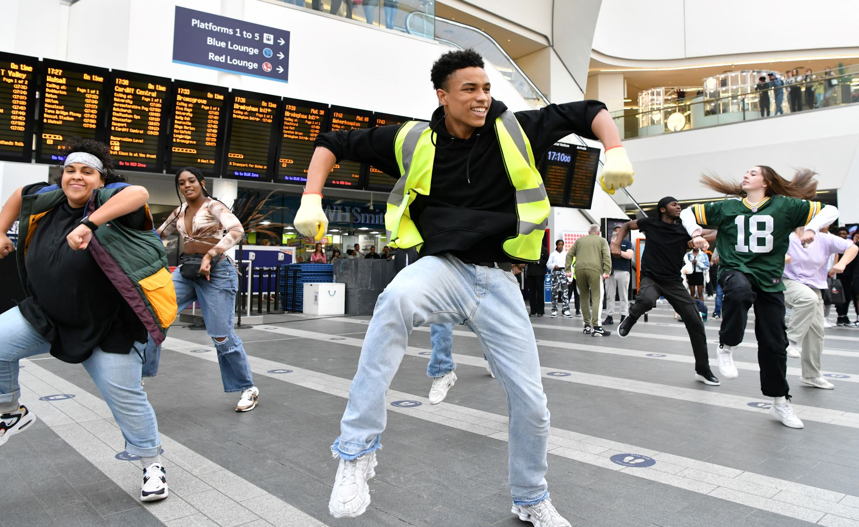

Saturday 23th August – Monday 25th August
12pm, 2pm, and 4.30pm

Time   | Saturday 23rd August – Monday 25th August  12pm, 2pm, 4.30pm  But you can come and go as you please.
Who is it for?   | Everyone!
Where is it?   | New Street Station - Concourse
Access   | There will be an Accessible Viewing Point near the Concourse. Access Hosts and signage will be present to help you find it.
Content warnings   |   The experience contains loud music.    It might get busy.
  Main themes |   Interactive experience      Dancing    Music

What will happen at this performance?

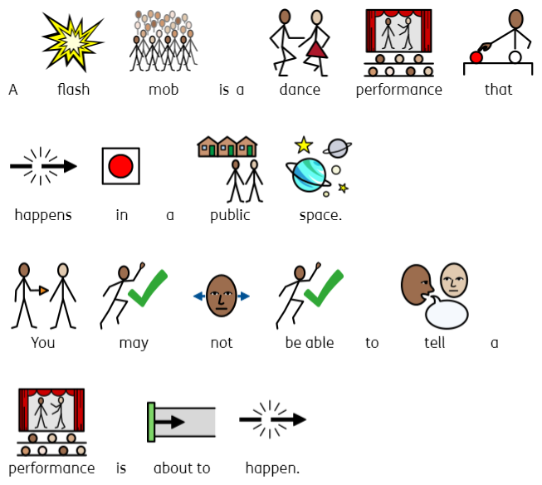

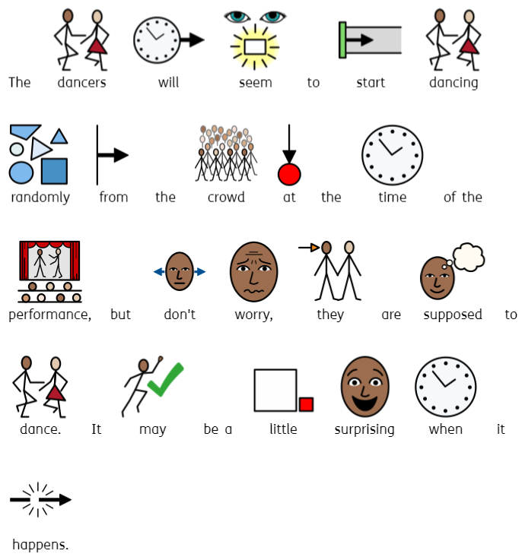

Contact us
charlotteboyer@briminghamhippodrome.com
ahlaammoledina@birminghamhippodrome.com

