Posse

by

Sound De Seca

Sunday 24th August &

Monday 25th August

12PM, 2:30PM & 5PM

|  |  |
| --- | --- |
|  | There will be 3 performances per day, at 12PM, 2.30PM, and 5PM.  Each performance lasts 45 minutes.  But you can come and go when you please |
| Who is it for?   | Everyone! |
| Where is it?   | Across the Bullring, beginning at St Martin’s Square    and ending at Rotunda Square. |
|  | There will be a signposted Accessible Viewpoint, and there will be live Audio Description at 5.30pm.  Chair Icon Vector Art, Icons, and Graphics for Free DownloadA black and white symbol of a wheelchair  AI-generated content may be incorrect. |
| Content warnings   | The music may be quite loud as there will be lots of drums and singing.   |
| A cartoon of a person's face with a light bulb above his head  AI-generated content may be incorrect.Main themes | A group of musical instruments  AI-generated content may be incorrect.  Live music |

What will happen during the performance?

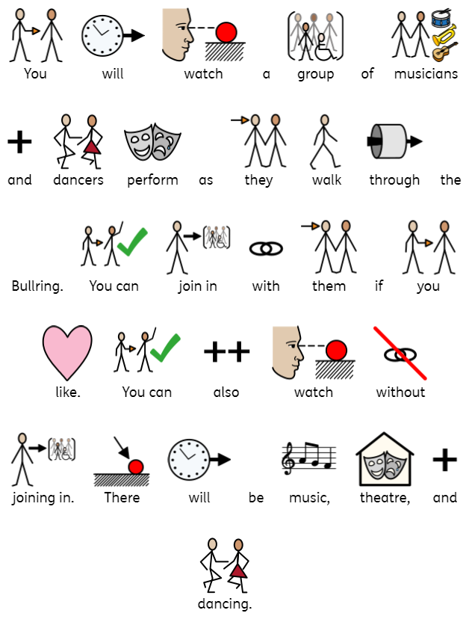

Find out more

<https://sounddeseca.com/en/posse-en/>

Contact us

[charlotteboyer@briminghamhippodrome.com](mailto:charlotteboyer@briminghamhippodrome.com)

[ahlaammoledina@birminghamhippodrome.com](mailto:ahlaammoledina@birminghamhippodrome.com)