Sashimi

By

The Vortexes

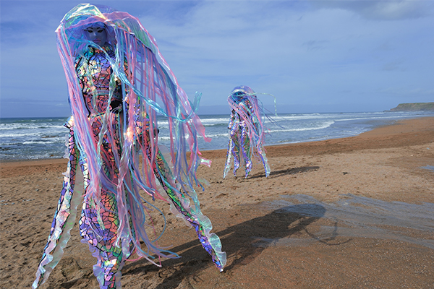

Monday 25th August
12.45PM, 3.15PM, and 5.30PM

Time   | Monday 25th August  At  12.45PM, 3.15PM, and 5.30PM  But you can come and go as you please.
Who is it for?   | Everyone!
Where is it?   | Across Bullring.
Access   | There will be Access Hosts to support you.
Content warnings   |   The piece is interactive.
Main themes   |     Theatre  

What will happen during the activity?

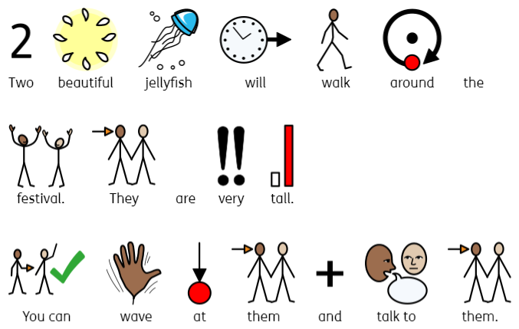

Find out more

https://www.foolsparadise.co.uk/companies/the-vortexes/sashimi/

Contact us
charlotteboyer@briminghamhippodrome.com
ahlaammoledina@birminghamhippodrome.com

