The Museum of Memorable Trees

By

Harry Pizzey Design

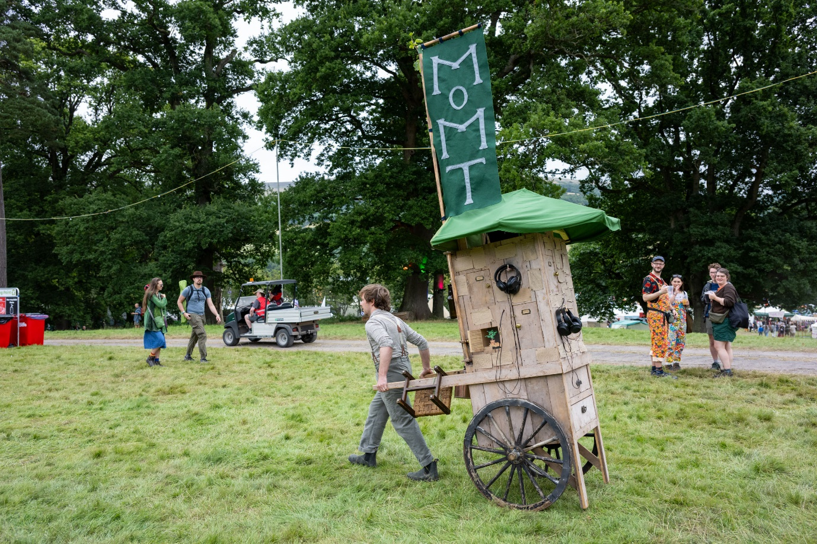

Saturday 23rd August – Sunday 24th August

1:30pm and 4pm

Time   | Saturday 23rd August – Sunday 24th August  1:30pm and 4pm.  Each performance is one hour.
Who is it for?   | All ages.
Where is it?   | Edgbaston Street and across Bullring.  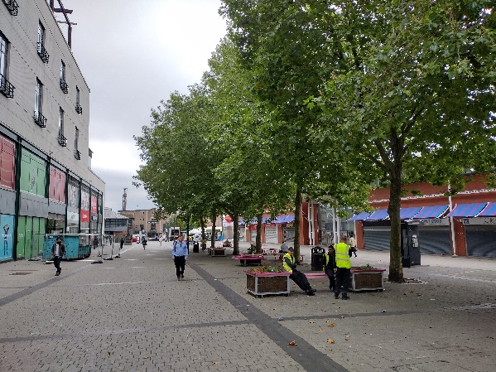
Access   |   The performance sometimes relies on speech.    It moderately relies on visuals.
Main themes   | 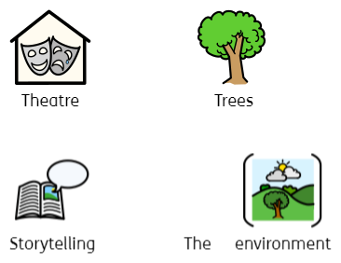

What will happen during the performance?

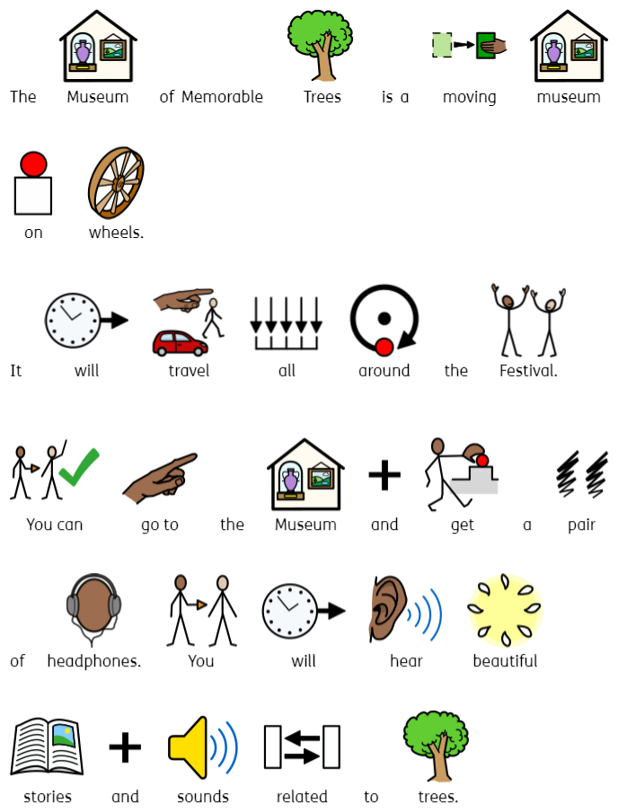
Find out more:

https://harrypizzeydesign.co.uk/index.php/2024/10/07/the-museum-of-memorable-trees/

Contact us:

Charlotteboyer@birminghamhippodrome.com
ahlaammoledina@birminghamhippodrome.com

