Waiting Project

Featuring…

Waiting Song - Mish Weaver

What are you waiting for?

Birmingham is waiting for… - Ayan Aden

Saturday 23rd August – Monday 25th August

12-6PM

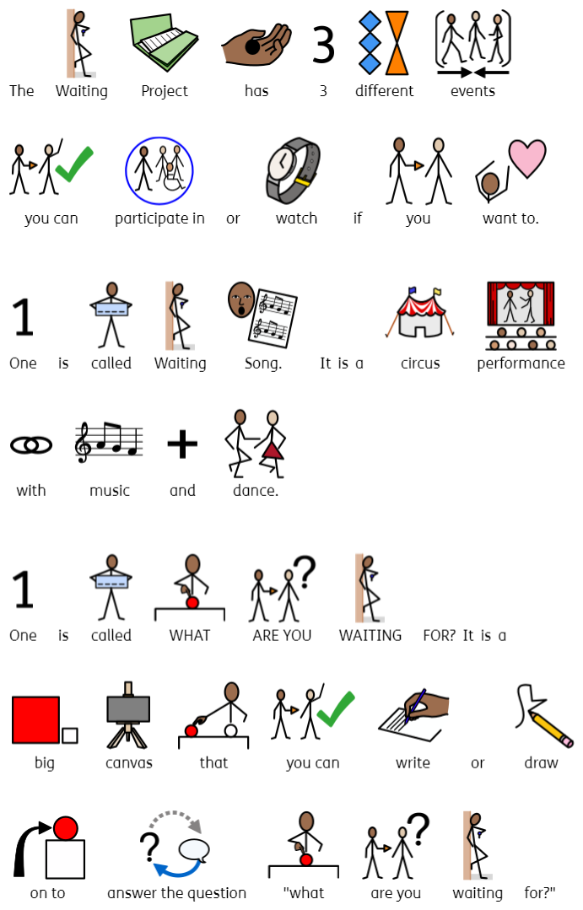

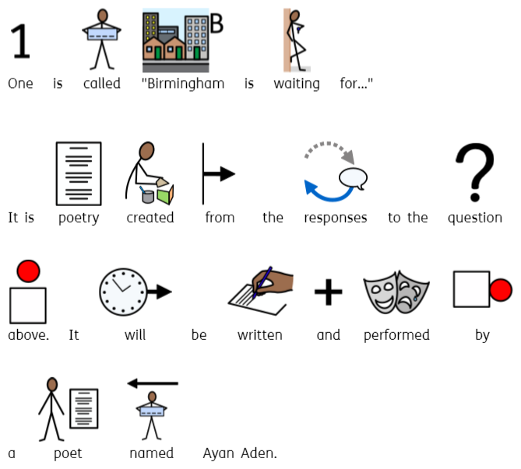

Waiting Song

|  |  |
| --- | --- |
|  | Saturday 23rd August to Monday 25th August.  12.45pm, 2.45pm, 4.45pm.  Each performance is 15 mins.  You can come and go as you please. |
| Who is it for?   | A group of people walking together  AI-generated content may be incorrect.All ages. |
| Where is it?   | It will take place at the New Street Station Concourse. |
|  | There will be an Accessible Viewpoint at the New Street Concourse  A black and white symbol of a wheelchair  AI-generated content may be incorrect.Chair Icon Vector Art, Icons, and Graphics for Free Download  There will be Audio Description at the 2.45pm performances on Saturday, Sunday, and Monday. There will be BSL at all performances, Saturday-Monday at 12.45pm, 2.45pm, and 4.45pm.  Audio Description - Screen Machine |
| Content Warnings   | A yellow megaphone with many points  AI-generated content may be incorrect.The performance might be loud.  A head with red headphones  AI-generated content may be incorrect.You can get ear defenders or ear plugs from the Accessible Viewpoint.  It may be very busy. |

What are you waiting for

|  |  |
| --- | --- |
|  | Saturday 23rd August – Monday 25th August  12-6pm. |
| Who is it for?   | A group of people walking together  AI-generated content may be incorrect.All ages. |
| Where is it?   | It will take place at the New Street Station Concourse. |
| Content Warnings   | It may be very busy. |

Birmingham is waiting for…

|  |  |
| --- | --- |
|  | Saturday 23rd August – Monday 25th August  3pm and 5.30pm  Each performance is 15 mins. |
| Who is it for?   | A group of people walking together  AI-generated content may be incorrect.All ages. |
| Where is it?   | It will take place at the New Street Station Concourse. |
|  | There will an Accessible Viewpoint at the New Street Concourse.  A black and white symbol of a wheelchair  AI-generated content may be incorrect.Chair Icon Vector Art, Icons, and Graphics for Free Download  There will be BSL interpretation at all performances. |
| Content Warnings   | A yellow megaphone with many points  AI-generated content may be incorrect.It might be loud.  A head with red headphones  AI-generated content may be incorrect.You can get ear defenders or ear plugs from the Accessible Viewpoint.  It may be very busy. |

Contact us

[Charlotteboyer@birminghamhippodrome.com](mailto:Charlotteboyer@birminghamhippodrome.com)

[Ahlaammoledina@birminghamhippodrome.com](mailto:Ahlaammoledina@birminghamhippodrome.com)