Weekender Carnival

By ACE DANCE AND MUSIC

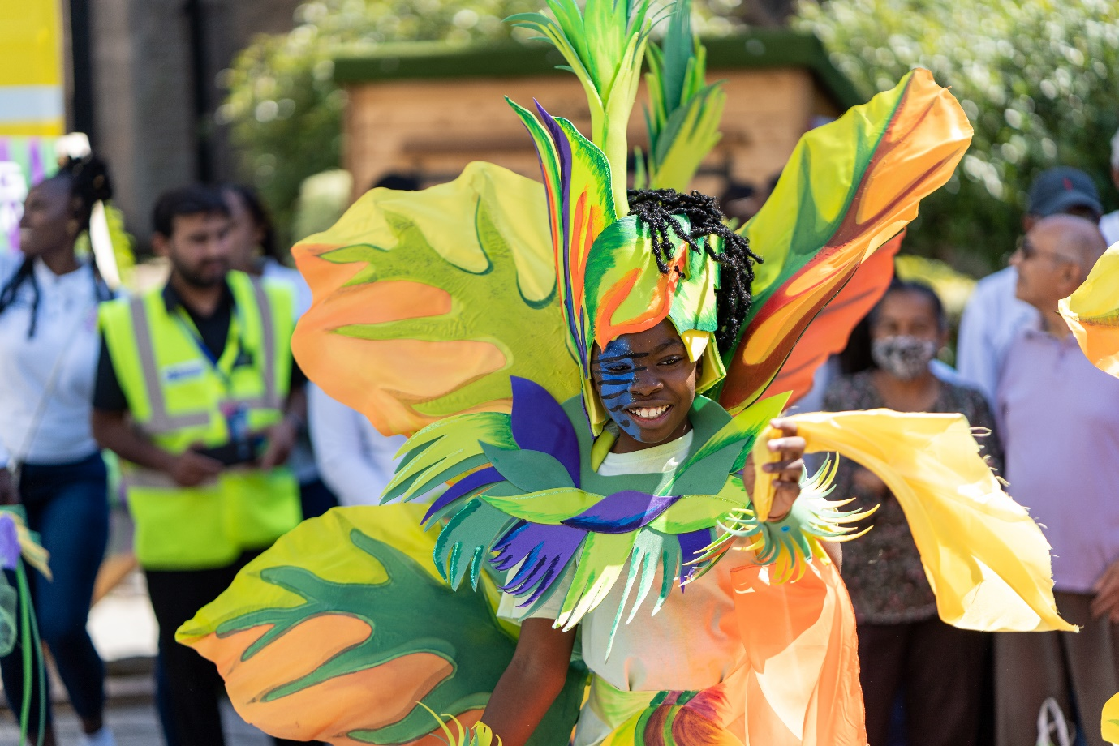

Saturday 23rd August
12-6PM

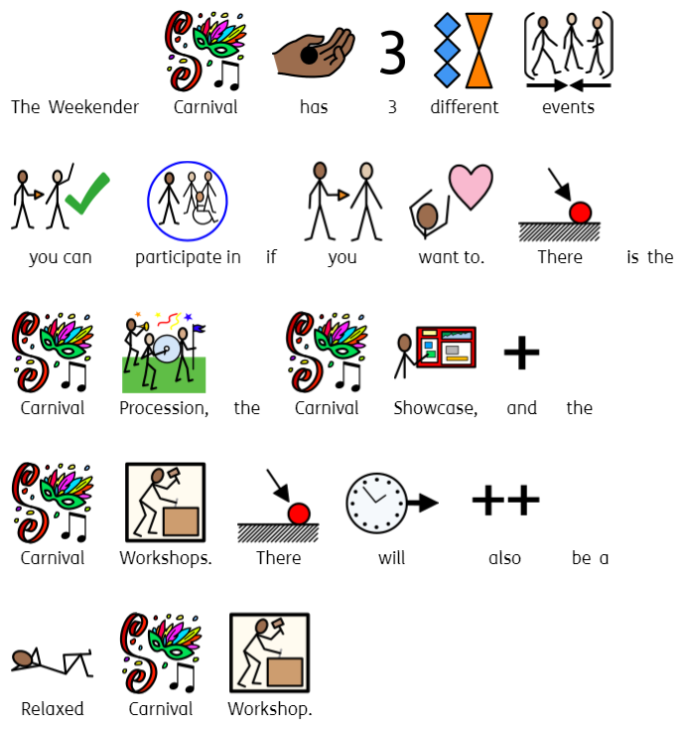

Weekender Carnival Procession

Time   | 12pm, 2.30pm, 5pm  Each performance is 45 mins.  You can come and go as you please.
Who is it for?   |   All ages.
Where is it?   | The Carnival procession will start at Edgbaston Road  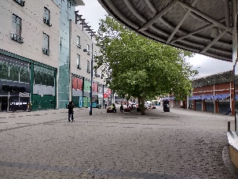  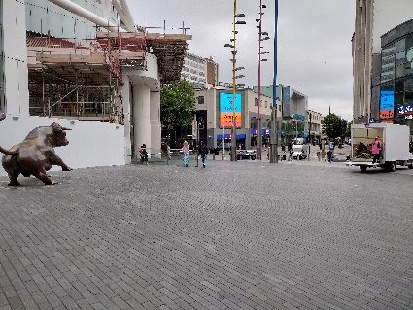  and end at Rotunda Square.
Access   | There will be an Accessible Viewpoint on Rotunda Square      There will be Audio Description at the 5.30pm performance.    There will be relaxed Carnival Workshops taking place from 1.30pm – 2.30pm and 4-5pm. These will take place at the Access Hub.
Content Warnings   |   The music might be loud.    You can get ear defenders or ear plugs from the Accessible Viewpoint.  It may be very busy.

Weekender Carnival Showcase

Time | 1pm and 3.45pm  Each performance is 30 mins.  You can come and go as you please.
Who is it for? | All ages.
Where is it? | 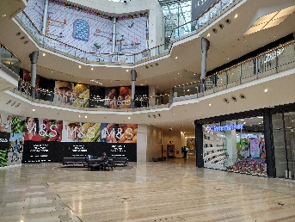  The Showcase will take place in Lower Mall West – Bullring (outside M&S)
Access | There will be an Accessible Viewpoint in the Bullring, on the middle floor, in front of HMV and Boots.  There will be Audio Description at the 1pm and 3.45pm peformances.  .
Content Warnings | The music might be loud.  You can get ear defenders or ear plugs from the Accessible Viewpoint.  It may be very busy.

Weekender Carnival Craft Workshops

Time | 1.30pm and 4pm  Each workshop is 1 hour.  You can come and go as you please.
Who is it for? | All ages.
Where is it? | 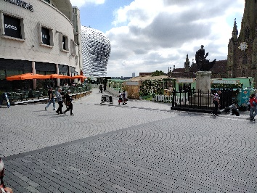  The workshops will take place in Chaophraya Square.
Access | There will be relaxed workshops taking place in the Access Hub if you want to be in a quieter space. They will be at 1.30pm and 4pm.
Content Warnings | The music might be loud.  You can get ear defenders or ear plugs from the Accessible Viewpoint.  It may be very busy.

Find out more

https://www.birminghamhippodrome.com/calendar/birmingham-weekender-2024/

Contact us

Charlotteboyer@birminghamhippodrome.com
Ahlaammoledina@birminghamhippodrome.com

