Hello and Welcome to Birmingham Weekender!

We have 3 FREE fun-filled days for you in Birmingham
from Saturday 29th August – Monday 31st August 2026.

This guide will tell you all about the different events and help you find them.

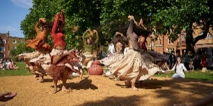
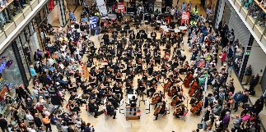
...there is dance   ... lots of music


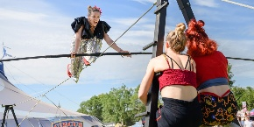
... all sorts of art   ... circus


and activities
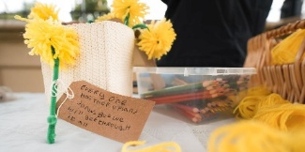




There are lots of performances that you can sit and watch as well as activities that you can take part in.



These are happening in specific places in Birmingham. There will be times that they will start and finish.

There is a lot of walking  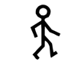 so wear comfortable shoes  and make sure you drink lots of water  if it is hot.


It will be busy when you are walking from one place to another as lots of people will be walking along the streets too.

We want everyone to enjoy Birmingham Weekender. At the festival we will have the following…


- Access hosts wearing yellow T-Shirts

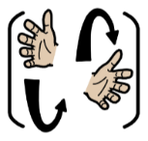

- British Sign Language (BSL) interpreters



- Audio Description



- Relaxed sessions/performances

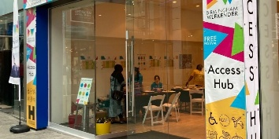

- An access hub with a chill-out space



- Access packs with ear defenders/plugs colour therapy


glasses and fidget toys

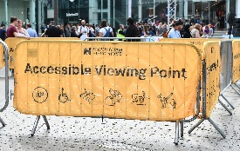

- Accessible viewpoints



- Pre-visit information on the website



- Radar keys to borrow

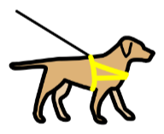


- Water bowls for assistance dogs






- Resources for keeping safe in the sun
Festival Locations

For information on parking/drop offs and toilets please visit our website https://www.birminghamhippodrome.com/birmingham-weekender-2026-access/
Location Name | Picture | What 3 Words/Google Maps Link
Chaophraya Square | 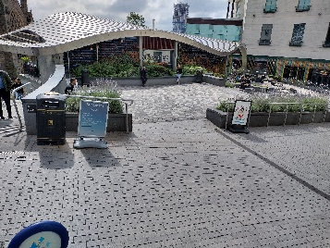 | ///plant.drops.elder  https://maps.app.goo.gl/FsxoU9EujL5eSLiy6
Bullring – Lower Mall West | 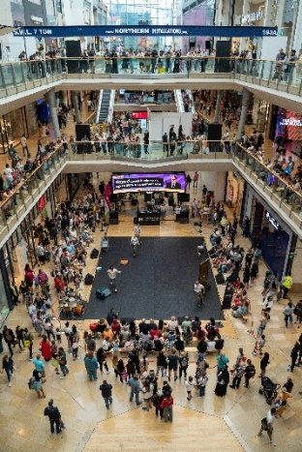 | ///drums.quit.minus  https://maps.app.goo.gl/AcLyyhAZTTFUWMcR6
Rotunda Square | 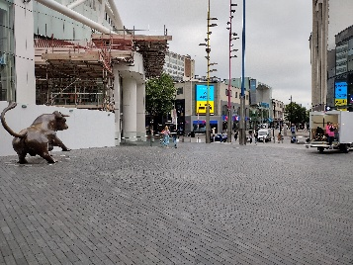 | ///wrong.festivity.flag  https://maps.app.goo.gl/EQDdRwGnqWiSWiwn9
St. Martin’s Square | 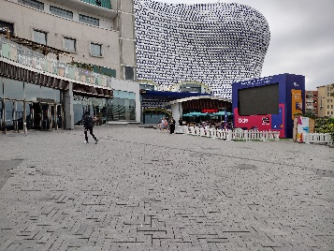 | ///pots.shift.jazz  https://maps.app.goo.gl/aFN6kjb1iGkN7Dn87
New Street Station Concourse | 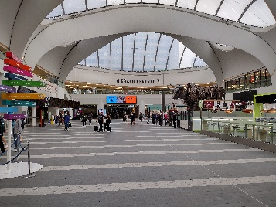 | ///arrive.timing.itself  https://maps.app.goo.gl/bbmsenVAL4bdLW7k6
New Street Station 1000 Trades Sqaure | 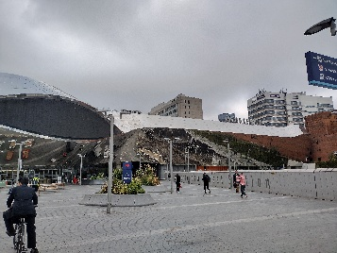 | ///hunter.works.stale  https://maps.app.goo.gl/h5emKJoAVdpnuisX8
Victoria Square | 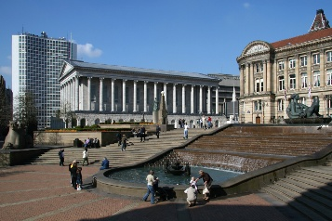 | ///farms.ledge.erase  https://maps.app.goo.gl/vr4mU8znkp98zNb8A
Central Street | 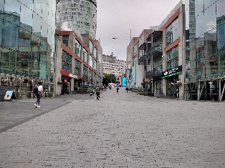  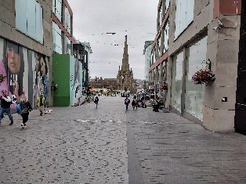 | ///fails.unwanted.puts  https://maps.app.goo.gl/newbPdKXc1sYyQRj8

Access Hub and Access and Information Points
Access hub – Rotunda Square (Sat 29th -Mon 31 Aug, 12pm-6pm)

An internal space near the Upper East Entrance of the Bullring.

At the Access Hub you can…

- Meet our access hosts.
- Find out about the programme and plan your day.
- Borrow access packs which include ear defenders/plugs colour therapy glasses and fidget toys.
- Have some water or fill up your water bottle.
- Take a break in our chill out zone.
- Take part in Relaxed Sessions.
- There will also be mindful crafts throughout the day.
- Borrow a radar key for the accessible toilets in Bullring.
- Borrow a water bowl for assistance animals.
- Borrow resources to keep yourself cool and safe in the sun.

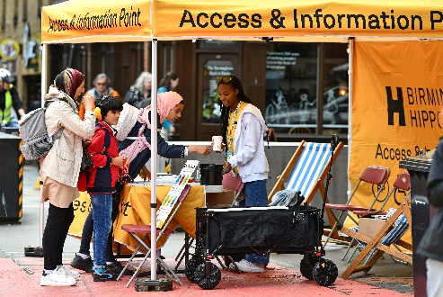

Access and information points – 1000 Trades Square/Victoria Square (Sat 29th -Mon 31 Aug, 12pm-6pm)

At the Access and information points you can…

- Meet our access hosts and volunteers
- Find out about the programme and pick up a brochure
- Borrow access packs which include ear defenders/plugs colour therapy glasses and fidget toys
- Take a seat and have some water or fill up your water bottle.
- Borrow a radar key for the accessible toilets in Bullring.
- Borrow a water bowl for assistance animals.

Shows and Events


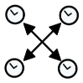
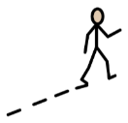

- You can come and go at any time during performances


- Many shows will have BSL and Audio Description
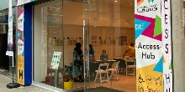

- We offer relaxed sessions of selected performances in our access hub



- There are easy-read guides available for each performance on our website

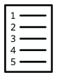


- The list below is all of our performances and events



- There will be another list grouped by access performances at the end of the guide




- You don’t need to book tickets, and everything is free

Events on all weekend

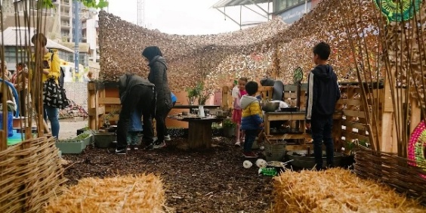  Photograph showing children and adults interacting in an outdoor garden or play area with wooden structures, plants, and natural materials like hay and woven fences. | Weekender Green Hub is a pop-up garden with activities and demonstrations all about gardening.  Time: 12pm-6pm  Location: Chaophraya Square  Access: Relaxed session supported by access hosts available 12pm-1pm.  View event page
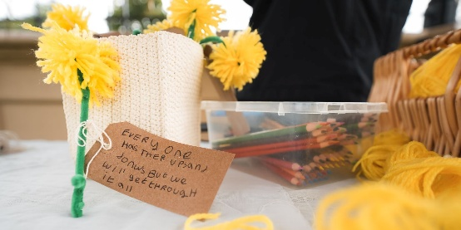  Photograph of a small bouquet of yellow woollen flowers with a handwritten note attached, placed on a table next to a container of colored pencils. Note reads, "Everyone has their ups and downs but we will get through it all," conveying a message of encouragement and support. | Walk of the Dandelion Craft Is open all day to create woolen flowers with positive messages.  Time: 12pm-6pm  Location: Chaophraya Square  Access: Relaxed session supported by access hosts available 12pm-1pm in Chaophraya Suare and 12pm-2pm in the Access Hub.  View event page
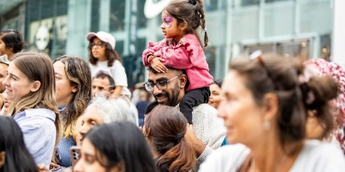  A photograph showing a group of people gathered outdoors, with a young girl sitting on a man's shoulders in the center. The scene captures a lively, communal atmosphere with individuals of various ages and backgrounds engaged in an event or gathering. | The Ideas Factory by HSBC UK is an interactive space of creativity, play and fun.  Time: 12pm-6pm  Location: Victoria Square  Access: Access and Information point based at Victoria Square  View event page
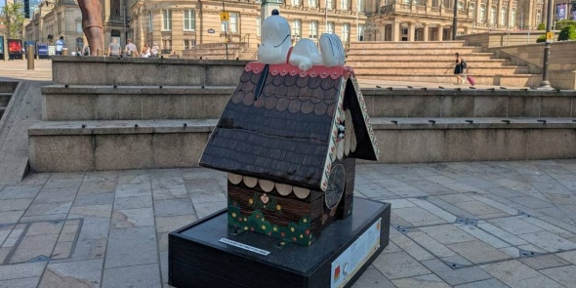  Photograph of a small decorative doghouse sculpture with Snoopy lying on its roof, placed on a black pedestal in Victoria Square in Birmingham. Background includes stone steps and a historic building, highlighting a public art installation. | Snoopy in Birmingham Family Trail is a trail to find all 12 Snoopy sculptures using a map.  Time: 12pm-6pm  Location: Across the festival  Access:  View event page
  Photograph of a young girl with butterfly face paint smiling while surrounded by colorful foam bubbles in shades of pink, white, and yellow. | Face Painting designs that you can choose from.  Time: 12pm-6pm  Location: Victoria Square  Access: The queues for face painting can be very long.  View event page
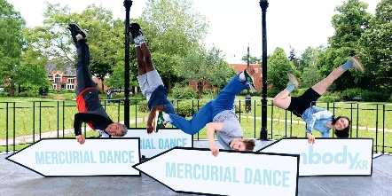  Photograph of four people performing handstands in a park with green trees and grass in the background. Three large white arrows with light blue text reading "MERCURIAL DANCE" and "bodyXR" overlay the lower part of the scene. | Sign Spinning performances involve tricks and movement with signs.  Time: 12pm-6pm  Location: Across the festival  Access: The signs are aimed to point you in the direction of the Ideas Factory on Victoria Square.  View event page
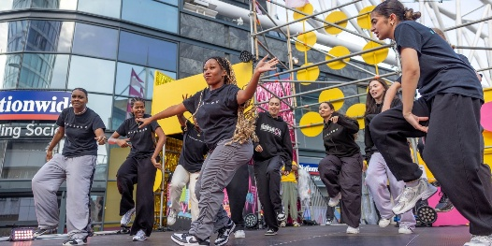  Photograph of a group of people dancing energetically outdoors in front of a modern building with large glass windows and colorful yellow circular decorations. Participants wear casual black and gray clothing. | Young Creatives Takeover @0121 Stage will have live music, dance, and DJs all programmed by the Hippodrome’s Young Advocates Group.  Themes include:  Saturday – Heavy Metal  Sunday – Pop  Monday – Carnival  Time: 12pm-6pm  Location: Victoria Square  Access: Access and Information point based at Victoria Square and BSL interpretation.  Access hosts can support you in finding a space to watch the performance.  View event page
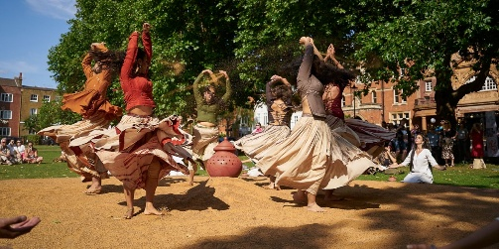  Photograph of a group of women performing a traditional dance outdoors on grass, with skirts swirling mid-spin and an audience seated in the background. The scene features vibrant clothing in earthy tones, lush green trees, and historic brick buildings under a clear blue sky. | Garbh is a dance piece celebrating feminine energy.  Times: 12pm and 3pm  Location: 1000 Trades Square  Access: BSL and tour tour/audio description at selected performances. Accessible viewpoint and access and information point available.  Relaxed session at Access Hub 2:45pm-4:15pm.  View event page
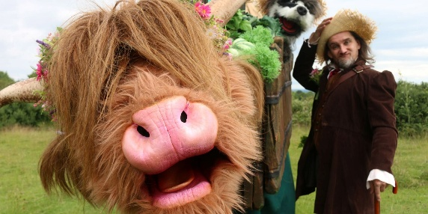  Photograph of a person dressed in rustic clothing and a straw hat standing next to a large, furry puppet resembling a Highland cow with prominent pink nose and horns. The puppet is decorated with greenery and flowers, set outdoors with a grassy field and cloudy sky in the background. | Moo is direct from the farmyard! Meet Mister Tatters and Hettie the Highland cow.  Times: 12pm, 2:15pm and 4:30pm  Location: Central Street  Access: Moo is a roaming performance so if you need support accessing this speak to an access host.  View event page
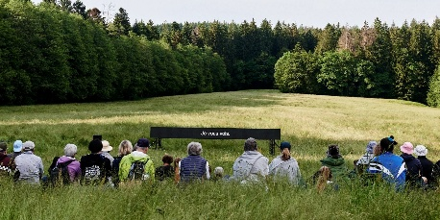  Photograph showing a group of people sitting on a bench facing a large open grassy field  bordered by dense green trees. A black sign with white text in French, "Je vous vois," is positioned in the middle of the field. | I Have No Name will display an LED screen with subtitles showing questions and thoughts.  Times: 12pm, 1pm, 2pm, 3pm, 4pm and 5pm  Location: St. Martin’s Square  Access: Accessible viewpoint available. BSL is available daily at 12pm.  View event page
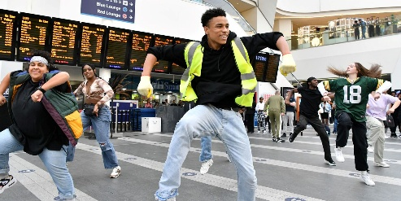  Photograph of a group of people dancing energetically in Birmingham New Street station, with a large digital departure board visible in the background. The central figure wears a neon yellow safety vest and gloves, highlighting a lively and spontaneous moment amid travelers. | Dance Flashmob is by Marshon dance company. A group of people will come together a perform a dance piece.  Times: 12:45pm, 2:30pm and 5:30pm  Location: New Street Station Concourse  Access: Audio description available at selected performances. Access hosts can support you in finding a space to watch the performance at our accessible viewpoint area.  View event page
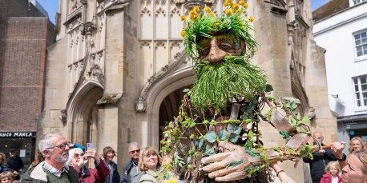  Photograph of a street performance featuring a large puppet resembling a green man with foliage and flowers integrated into its design, standing in front of a historic stone building. The puppet is surrounded by a crowd of onlookers, some taking photos, highlighting a lively outdoor event with an emphasis on nature and folklore themes. | Walk of the Dandelion involves meeting Daniel the 8 foot puppet who spreads joy. You can give him flowers you made in the craft activity.  Times: 12:45pm, 3pm and 5:15pm  Location: Central Street  Access: This is a roaming performance so if you need support accessing this speak to an access host.  View event page
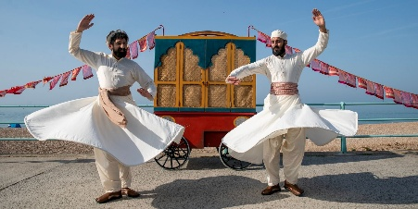  Photograph of two men dressed in traditional white whirling dervish attire performing a spinning dance on a beach with a colorful wooden cart and red flags in the background. Both men have raised arms and flowing skirts, capturing motion and cultural expression against a clear blue sky. | Kismat Walla captures the bustling atmosphere of South Asian markets using puppetry.  Times: 1:15pm and 4:30pm  Location: 1000 Trades Square  Access: BSL and audio description at selected performances. Accessible viewpoint and access and information point available.  Relaxed session at the access Hub at 2:15pm every day.  View event page
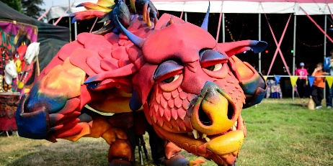  Photograph of a large, colorful dragon puppet with red, orange, and blue hues displayed outdoors on grass near a tent. The dragon features detailed scales, expressive eyes, and prominent nostrils. | Epico the Dragon is fresh out of the lair! Meet Sir Aurelious Jones and he attempts to tame the dragon.  Times: 1:30pm and 3:45pm  Location: Central Street  Access: This is a roaming performance so if you need support accessing this speak to an access host.  View event page
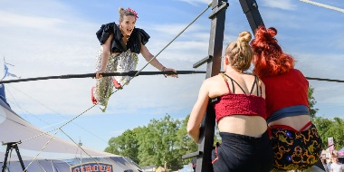  Photograph of a female tightrope walker performing outdoors, balancing on a wire with arms extended for stability. Two spectators with colorful clothing watch closely from below, with circus tents and trees visible in the background under a clear blue sky. | Elevate Her is a joyous all female wire walking show.  Times: 2pm and 4:15pm  Location: Victoria Square  Access: Access hosts can support you in finding a space to watch the performance.  Access and information point available.  View event page

Events on Saturday 29th August

  Photograph of a female DJ posing with red headphones extended toward the camera against a blue background with colorful geometric shapes. Text "DJ EMKAY" appears below, highlighting the DJ's name. | Always K-Pop brings a vibrant, family-friendly celebration of Korean music and culture to Mirror Bull City.  Time: 12pm-6pm  Location: Mirror Bull City – Rotunda Square  Access: Mirror Bull City is an immersive installation featuring hundreds of mirror/disco balls, lighting and music. Bright reflections and light effects form part of the experience. Those with light sensitivities may wish to consider effects before visiting.  Ear defenders/plugs and colour therapy glasses will be available.  There will be a Mirror Bull City inspired relaxed session in the access hub.  View event page
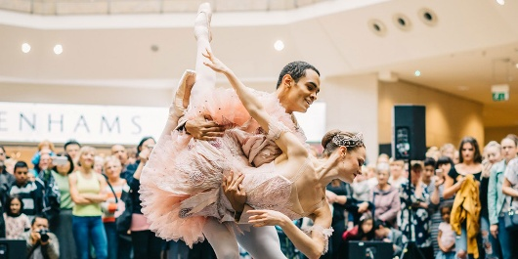  Photograph of two ballet dancers performing in the Bullring with a crowd watching in the background. The dancers wear pink tutus and ballet shoes, showcasing strength and grace, while the audience captures the moment with phones and cameras. | Discover Birmingham Royal Ballet in a dance showcase.  Time: 12pm-1pm and 1pm-2pm  Location: Bullring – Lower Mall West  Access: Audio Description available. Accessible viewpoint available.  View event page
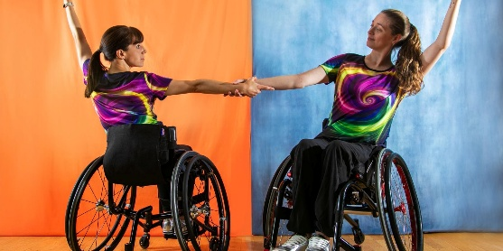  Photograph of two wheelchair users performing a dance routine, holding hands and extending their arms against a split orange and blue background. Both wear matching colorful swirl-patterned shirts, showcasing strength, coordination, and inclusivity in adaptive dance. | Join in with the Propel Dance Takeover which includes short performances and a workshop.  Times: 2pm and 4:15pm  Location: Bullring – Lower Mall West  Access: Audio Description available at 2pm and BSL available at 4:15pm. Accessible viewpoint available.  View event page
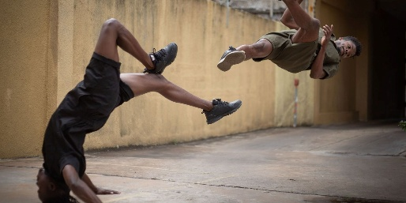  Photograph of two young men performing acrobatic flips in an outdoor alley with yellow walls. One person is upside down with hands on the ground while the other is mid-air, showcasing dynamic movement and athletic skill. | Otempodiz is a physical theatre piece about time.  Times: 2pm and 4pm  Location: New Street Station Concourse  Access: Audio Description at 2pm. Access hosts can support you in finding a space to watch the performance at our accessible viewpoint area.  View event page
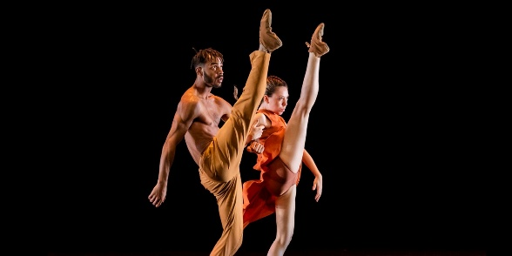  Photograph of two contemporary dancers performing against a black background, with both raising one leg high in a synchronized pose. The male dancer wears tan pants, and the female dancer wears an orange dress, highlighting their strength and flexibility. | The Sao Paulo Dance Company Curtain Raiser includes young dancers who have created a piece with the Sao Paulo Dance Company.  Times: 2pm and 4pm  Location: Bullring – Lower Mall West  Access: Audio Description available at 4pm. Accessible viewpoint available.  View event page

Events on Sunday 30th August

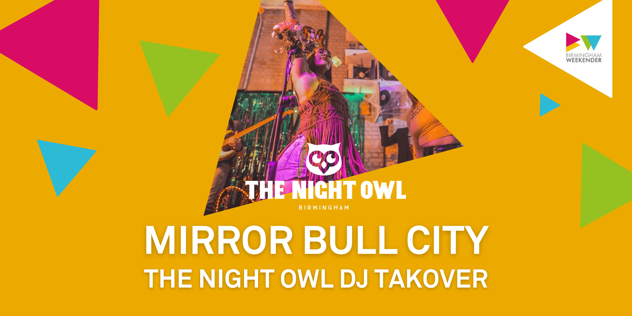  Promotional poster featuring a photograph of a DJ performing at The Night Owl in Birmingham, with colorful geometric shapes on an orange background. Text highlights "Mirror Bull City" and "The Night Owl DJ Takeover”. | The Night Owl brings three DJ’s playing funk, soul, disco, Motown and northern soul.  Time: 12pm-6pm  Location: Mirror Bull City – Rotunda Square  Access: Mirror Bull City is an immersive installation featuring hundreds of mirror/disco balls, lighting and music. Bright reflections and light effects form part of the experience. Those with light sensitivities may wish to consider effects before visiting.  Ear defenders/plugs and colour therapy glasses will be available.  There will be a Mirror Bull City inspired realxed session in the access hub.  View event page
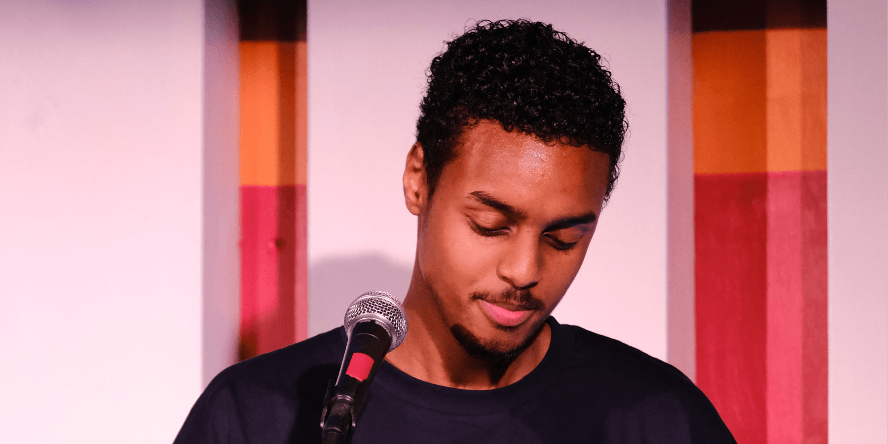  Photograph of a young man with curly hair speaking into a microphone. Background features vertical stripes in orange, red, and pink tones, adding a colorful and warm atmosphere. | Join Zakariye as Birmingham Weekender’s Poet in Residence. Telling poems about what makes the festival unique.  Times: 12:30pm, 2:30pm and 3:30pm  Location: Bullring – Lower Mall West  Access: BSL available at all performances. Accessible viewpoint available.  View event page
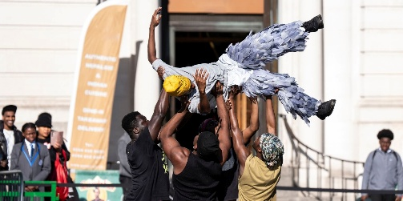  Photograph of a group of people outdoors performing a celebratory lift, with one person raised horizontally above others' heads. The lifted individual wears a yellow headwrap and feathered pants, while onlookers in the background watch and smile near a building entrance. | Fragments of Us is centered around a cast of black boys and men exploring themes of identity and resilience through physical theatre.  Times: 1pm and 4pm  Location: Bullring – Lower Mall West  Access: Audio description available at 1pm. Accessible viewpoint available.  View event page
Photograph of two young men performing acrobatic flips in an outdoor alley with yellow walls. One person is upside down with hands on the ground while the other is mid-air, showcasing dynamic movement and athletic skill. | Otempodiz is a physical theatre piece about time.  Times: 2pm and 4pm  Location: New Street Station Concourse  Access: Audio Description at 2pm. Access hosts can support you in finding a space to watch the performance at our accessible viewpoint area.  View event page

Events on Monday 31st August

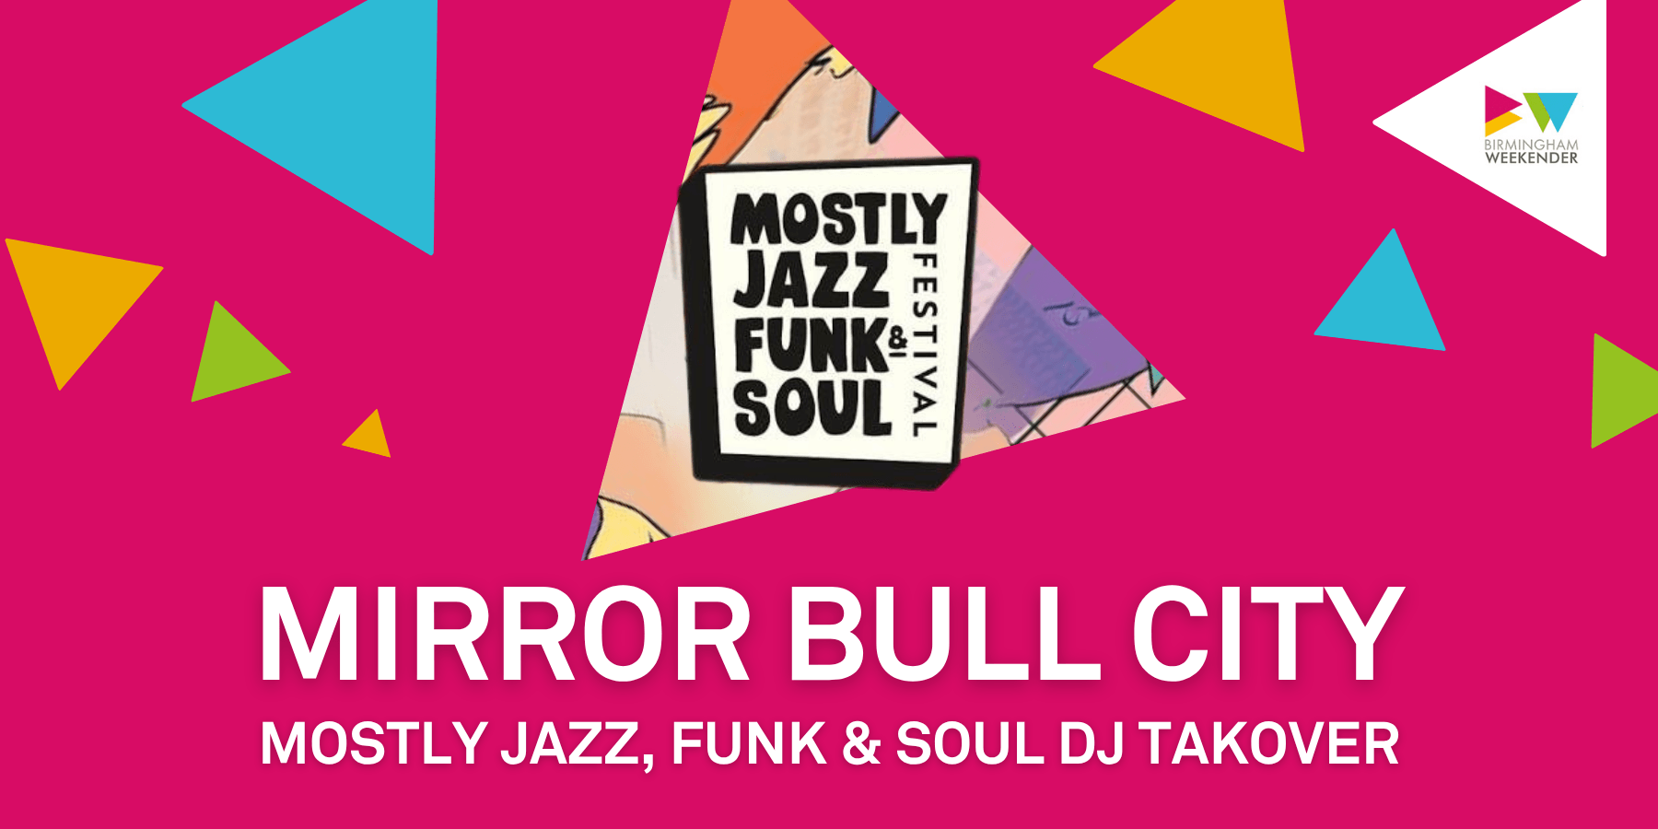  Promotional graphic for Mirror Bull City event featuring Mostly Jazz, Funk & Soul DJ takeover, with vibrant pink background and colorful geometric shapes. Logo for Mostly Jazz Funk Soul Festival appears in black and white within a triangle, emphasizing music genres and event branding. | Mostly Jazz, Funk and Soul celebrates the final day of the festival with DJs.  Time: 12pm-6pm  Location: Mirror Bull City – Rotunda Square  Access: Mirror Bull City is an immersive installation featuring hundreds of mirror/disco balls, lighting and music. Bright reflections and light effects form part of the experience. Those with light sensitivities may wish to consider effects before visiting.  Ear defenders/plugs and colour therapy glasses will be available.]  There will be a Mirror Bull City inspired realxed session in the Access Hub.  View event page
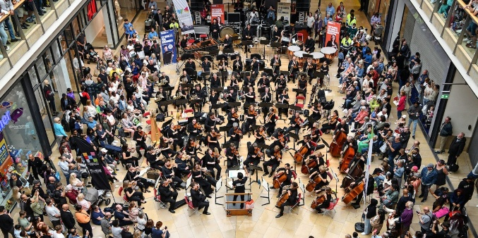  Photograph of a large orchestra performing in the Bullring surrounded by a crowd of seated and standing spectators. Musicians are arranged in sections with string, brass, woodwind, and percussion instruments, while the conductor stands on a podium in the center. | CBSO in the City showcases the City of Birmingham Symphony Orchestra playing classical music.  Times: 1pm and 3pm  Location: Bullring – Lower Mall West  Access: Audio description available at 1pm. Accessible viewpoint available.  View event page
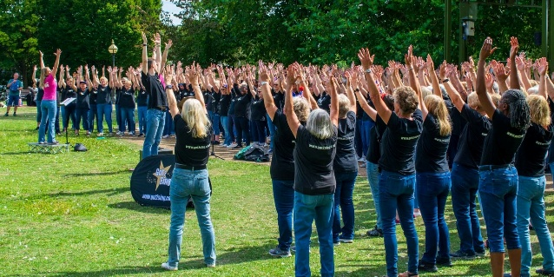  A photograph of a large choir with participants wearing matching black shirts and blue jeans, raising their arms in unison on a grassy area surrounded by trees. The scene includes a banner on the ground and a few instructors leading the activity, highlighting community engagement and | Got 2 Sing Choir will sing a fantastic mix of songs.  Times: 2pm and 4pm  Location: New Street Station Concourse  Access: BSL at 4pm. Access hosts can support you in finding a space to watch the performance at our accessible viewpoint area.  View event page

Shows and events – Accessible Performances

These timetables tell you about what access performances are happening on each day.

Saturday 29th August

Accessible Viewing Points
Piece | Time | Location
Young Creatives Takeover @0121 Stage | 12pm-6pm | Victoria Square
I Have No Name – El Conde de Torrefiel | 12pm-12:30pm | St. Martin’s Sqaure
Garbh – Shyam Dattani and Mira Salat | 12pm-12:40pm | 1000 Trades Square
Birmingham Royal Ballet Showcase | 12pm-1pm | Bullring- Lower Mall West
Dance Flashmob – Marshon | 12:45pm-12:55pm | New Street Station Concourse
I Have No Name – El Conde de Torrefiel | 1pm-1:30pm | St. Martin’s Square
Birmingham Royal Ballet Showcase | 1pm-2pm | Bullring- Lower Mall West
Kismat Walla – Thingumajig Theatre | 1:15pm-2pm | 1000 Trades Square
Sao Paulo Dance Company Curtain Raiser | 2pm-2:10pm | Bullring – Lower Mall West
Otempodiz - Ertza | 2pm-2:15pm | New Street Station Concourse
I Have No Name – El Conde de Torrefiel | 2pm-2:30pm | St. Martin’s Square
Elevate Her – Daughters of the Wire | 2pm-2:40pm | Victoria Square
Propel Dance Takeover | 2:15pm-4pm | Bullring- Lower Mall West
Dance Flashmob – Marshon | 2:30pm-2:40pm | New Street Station Concourse
Garbh – Shyam Dattani and Mira Salat | 3pm-3:40pm | 1000 Square
I Have No Name – El Conde de Torrefiel | 3pm-3:30pm | St. Martin’s Square
Otempodiz - Ertza | 4pm-4:15pm | New Street Station Concourse
I Have No Name – El Conde de Torrefiel | 4pm-4:30pm | St. Martin’s Sqaure
Sao Paulo Dance Company Curtain Raiser | 4pm-4:10pm | Bullring – Lower Mall West
Elevate Her – Daughters of the Wire | 4:15pm-4:55pm | Victoria Square
Propel Dance Takeover | 4:15pm-6pm | Bullring- Lower Mall West
Kismat Walla – Thingumajig Theatre | 4:30pm-5:15pm | 1000 Trades Square
I Have No Name – El Conde de Torrefiel | 5pm-5:30pm | St. Martin’s Square
Dance Flashmob – Marshon | 5:30pm-5:40pm | New Street Station Concourse
Audio Description
Piece | Time(s) | Location
Garbh – Shyam Dattani and Mira Salat | 12pm-12:40pm | 1000 Trades Square
Dance Flashmob – Marshon | 12:45pm-12:55pm | New Street Station Concourse
Birmingham Royal Ballet Showcase | 12pm-1pm | Bullring – Lower Mall West
Birmingham Royal Ballet Showcase | 1pm-2pm | Bullring – Lower Mall West
Otempodiz – Ertza | 2pm-2:15pm | New Street Station Concourse
Propel Dance Takeover | 2:15pm-4pm | Bullring – Lower Mall West
Garbh – Shyam Dattani and Mira Salat | 2:30pm-3:40pm (Touch Tour – 2:30pm-2:50pm & performance – 3pm-3:40pm) | 1000 Trades Square
Sao Paulo Dance Company Curtain Raiser | 4pm-4:10pm | Bullring – Lower Mall West
Kismat Walla | 4:10pm-5:15pm | 1000 Trades Square

BSL Interpretation
Piece | Time | Location
Young Creatives Takeover @0121 Stage | 12pm-6pm | Victoria Square
I Have No Name | 12pm-12:30pm | St. Martin’s Square
Kismat Walla | 1:15pm-2pm | 1000 Trades Square
Elevate Her | 2pm-2:40pm | Victoria Square
Elevate Her | 4:15pm-4:55pm | Victoria Square
Propel Dance Takeover | 4:15pm-6pm | Bullring-Lower Mall West

Relaxed Sessions
Piece | Time(s) | Location
Weekender Green Hub | 12pm-1pm | Chaophraya Square
Walk of the Dandelion – CRAFT | 12pm-1pm | Chaophraya Square
Walk of the Dandelion – CRAFT | 12pm-2pm | Access Hub
Garbh Inspired Sensory Activity | 2:45pm-4:15pm | Access Hub
Mirror Bull City Inspired Sensory Activity | 4:30pm-6pm | Access Hub

Sunday 30th August

Accessible Viewing Points
Piece | Time | Location
Young Creatives Takeover @0121 Stage | 12pm-6pm | Victoria Square
I Have No Name – El Conde de Torrefiel | 12pm-12:30pm | St. Martin’s Sqaure
Garbh – Shyam Dattani and Mira Salat | 12pm-12:40pm | 1000 Trades Square
Dance Flashmob – Marshon | 12:45pm-12:55pm | New Street Station Concourse
I Have No Name – El Conde de Torrefiel | 1pm-1:30pm | St. Martin’s Square
Fragments of Us – Talawa Theatre | 1pm-1:45pm | Bullring-Lower Mall West
Kismat Walla – Thingumajig Theatre | 1:15pm-2pm | 1000 Trades Square
Spoken Word Sessions | 12:30pm-12:40pm | Bullring-Lower Mall West
Otempodiz – Ertza | 2pm-2:15pm | New Street Station Concourse
I Have No Name – El Conde de Torrefiel | 2pm-2:30pm | St. Martin’s Square
Elevate Her – Daughters of the Wire | 2pm-2:40pm | Victoria Square
Dance Flashmob – Marshon | 2:30pm-2:40pm | New Street Station Concourse
Spoken Word Sessions | 2:30pm-2:40pm | Bullring-Lower Mall West
Garbh – Shyam Dattani and Mira Salat | 3pm-3:40pm | 1000 Square
I Have No Name – El Conde de Torrefiel | 3pm-3:30pm | St. Martin’s Square
Spoken Word Sessions | 3:30pm-3:40pm | Bullring-Lower Mall West
Otempodiz – Ertza | 4pm-4:15pm | New Street Station Concourse
I Have No Name – El Conde de Torrefiel | 4pm-4:30pm | St. Martin’s Square
Fragments of Us – Talawa Theatre | 4pm-4:45pm | Bullring-Lower Mall West
Elevate Her – Daughters of the Wire | 4:15pm-4:55pm | Victoria Square
Kismat Walla – Thingumajig Theatre | 4:30pm-5:15pm | 1000 Trades Square
I Have No Name – El Conde de Torrefiel | 5pm-5:30pm | St. Martin’s Square
Dance Flashmob – Marshon | 5:30pm-5:40pm | New Street Station Concourse

Audio Description
Piece | Time(s) | Location
Garbh – Shyam Dattani and Mira Salat | 12pm-12:40pm | 1000 Trades Square
Dance Flashmob – Marshon | 12:45pm-12:55pm | New Street Station Concourse
Fragments of Us – Talawa Theatre | 1pm-1:45pm | Bullring – Lower Mall West
Otempodiz – Ertza | 2pm-2:15pm | New Street Station Concourse
Elevate Her – Daughters of the Wire | 2pm-2:40pm | Victoria Square
Garbh – Shyam Dattani and Mira Salat | 2:30pm-3:40pm (Touch Tour – 2:30pm-2:50pm & performance – 3pm-3:40pm) | 1000 Trades Square
Kismat Walla | 4:10pm-5:15pm | 1000 Trades Square

BSL Interpretation
Piece | Time | Location
Young Creatives Takeover @0121 Stage | 12pm-6pm | Victoria Square
I Have No Name | 12pm-12:30pm | St. Martin’s Square
Spoken Word Sessions | 12:30pm-12:40pm | Bullring – Lower Mall West
Kismat Walla | 1:15pm-2pm | 1000 Trades Square
Elevate Her | 2pm-2:40pm | Victoria Square
Spoken Word Sessions | 2:30pm-2:40pm | Bullring – Lower Mall West
Spoken Word Sessions | 3:30pm-3:40pm | Bullring – Lower Mall West
Elevate Her | 4:15pm-4:55pm | Victoria Square

Relaxed Sessions
Piece | Time(s) | Location
Weekender Green Hub | 12pm-1pm | Chaophraya Square
Walk of the Dandelion – CRAFT | 12pm-1pm | Chaophraya Square
Walk of the Dandelion – CRAFT | 12pm-2pm | Access Hub
Garbh Inspired Sensory Activity | 2:45pm-4:15pm | Access Hub
Mirror Bull City Inspired Sensory Activity | 4:30pm-6pm | Access Hub

Monday 31st August

Accessible Viewing Points
Piece | Time | Location
Young Creatives Takeover @0121 Stage | 12pm-6pm | Victoria Square
I Have No Name – El Conde de Torrefiel | 12pm-12:30pm | St. Martin’s Square
Garbh – Shyam Dattani and Mira Salat | 12pm-12:40pm | 1000 Trades Square
Dance Flashmob – Marshon | 12:45pm-12:55pm | New Street Station Concourse
I Have No Name – El Conde de Torrefiel | 1pm-1:30pm | St. Martin’s Square
CBSO In the City | 1pm-1:45pm | Bullring – Lower Mall West
Kismat Walla – Thingumajig Theatre | 1:15pm-2pm | 1000 Trades Square
Got 2 Sing Choir | 2pm-2:15pm | New Street Station Concourse
I Have No Name – El Conde de Torrefiel | 2pm-2:30pm | St. Martin’s Square
Elevate Her – Daughters of the Wire | 2pm-2:40pm | Victoria Square
Dance Flashmob – Marshon | 2:30pm-2:40pm | New Street Station Concourse
Garbh – Shyam Dattani and Mira Salat | 3pm-3:40pm | 1000 Square
CBSO In the City | 3pm-3:45pm | Bullring – Lower Mall West
I Have No Name – El Conde de Torrefiel | 3pm-3:30pm | St. Martin’s Square
Got 2 Sing Choir | 4pm-4:15pm | New Street Station Concourse
I Have No Name – El Conde de Torrefiel | 4pm-4:30pm | St. Martin’s Square
Elevate Her – Daughters of the Wire | 4:15pm-4:55pm | Victoria Square
Kismat Walla – Thingumajig Theatre | 4:30pm-5:15pm | 1000 Trades Square
I Have No Name – El Conde de Torrefiel | 5pm-5:30pm | St. Martin’s Square
Dance Flashmob – Marshon | 5:30pm-5:40pm | New Street Station Concourse

Audio Description
Piece | Time(s) | Location
Garbh – Shyam Dattani and Mira Salat | 12pm-12:40pm | 1000 Trades Square
CBSO In the City | 1pm-1:45pm | Bullring – Lower Mall West
Elevate Her – Daughters of the Wire | 2pm-2:40pm | Victoria Square
Dance Flashmob – Marshon | 2:30pm-2:40pm | New Street Station Concourse
Garbh – Shyam Dattani and Mira Salat | 2:30pm-3:40pm (Touch Tour – 2:30pm-2:50pm & performance – 3pm-3:40pm) | 1000 Trades Square
Kismat Walla | 4:10pm-5:15pm | 1000 Trades Square

BSL Interpretation
Piece | Time | Location
Young Creatives Takeover @0121 Stage | 12pm-6pm | Victoria Square
I Have No Name | 12pm-12:30pm | St. Martin’s Square
Kismat Walla | 1:15pm-2pm | 1000 Trades Square
Elevate Her | 2pm-2:40pm | Victoria Square
Got To Sing Choir | 4pm-4:15pm | New Street Station Concourse
Elevate Her | 4:15pm-4:55pm | Victoria Square

Relaxed Sessions
Piece | Time(s) | Location
Weekender Green Hub | 12pm-1pm | Chaophraya Square
Walk of the Dandelion – CRAFT | 12pm-1pm | Chaophraya Square
Walk of the Dandelion – CRAFT | 12pm-2pm | Access Hub
Kismat Walla | 2:15pm-2:30pm | Access Hub
Garbh Inspired Sensory Activity | 2:45pm-4:15pm | Access Hub
Mirror Bull City Inspired Sensory Activity | 4:30pm-6pm | Access Hub

