Fragments of Us

by

Talawa Theatre Company

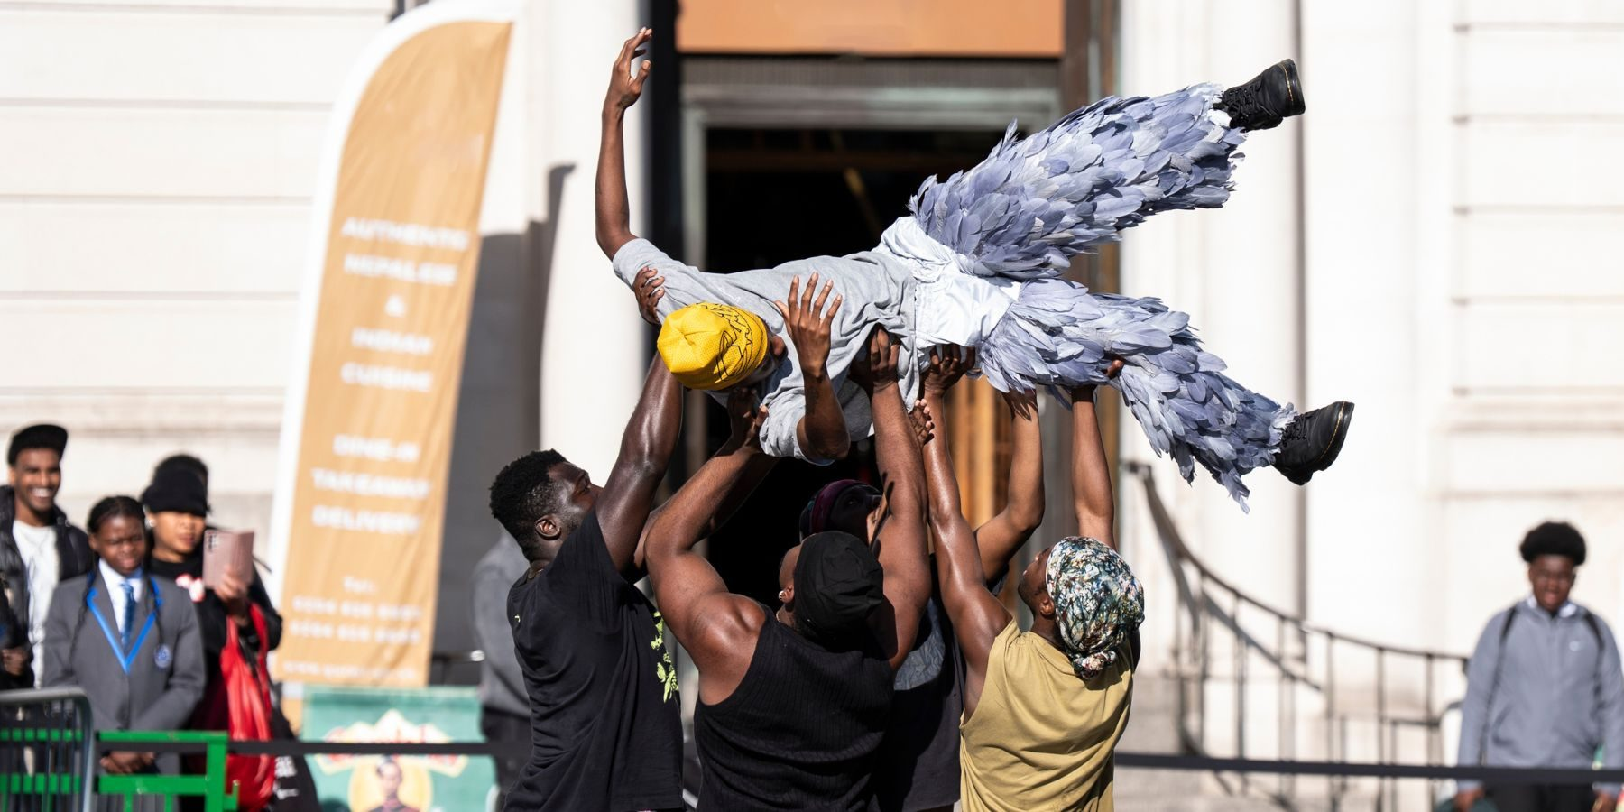

Sunday 30th August

Time   | 1-1.40pm  4-4.40pm  But you can come and go as you please.
Who is it for?   |   Everyone!
Where is it?   | Inside Bullring – Lower Mall West  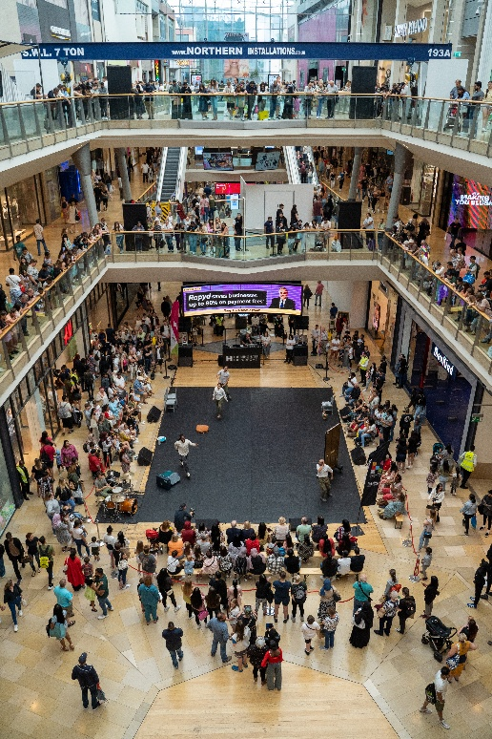
Access   | Audio Description:  Sunday 30th August  1-1.40pm    There are signposted Accessible Viewpoints on the ground floor of Bullring, and on the middle level outside HMV and Boots.        There will be Access Hosts nearby in yellow t-shirts and yellow hats to support you.  There will be no speech.  There will be no text.
Content warnings   | It may be loud.  There may be crowds.    Contains themes of race and identity.
Main themes   |   Dance    Movement  Race and Identity    Brotherhood    Storytelling

What will happen during the activity?
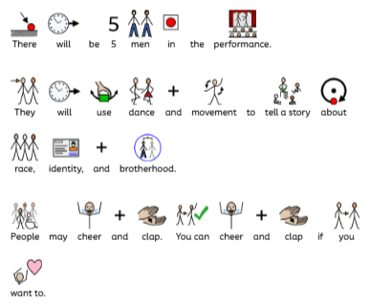

Find out more
https://talawa.com/

https://www.birminghamhippodrome.com/calendar/fragments-of-us/

Contact us
charlotteboyer@briminghamhippodrome.com
aadildin@birminghamhippodrome.com

