Garbh

by

Shyam Dattani and Mira Salat

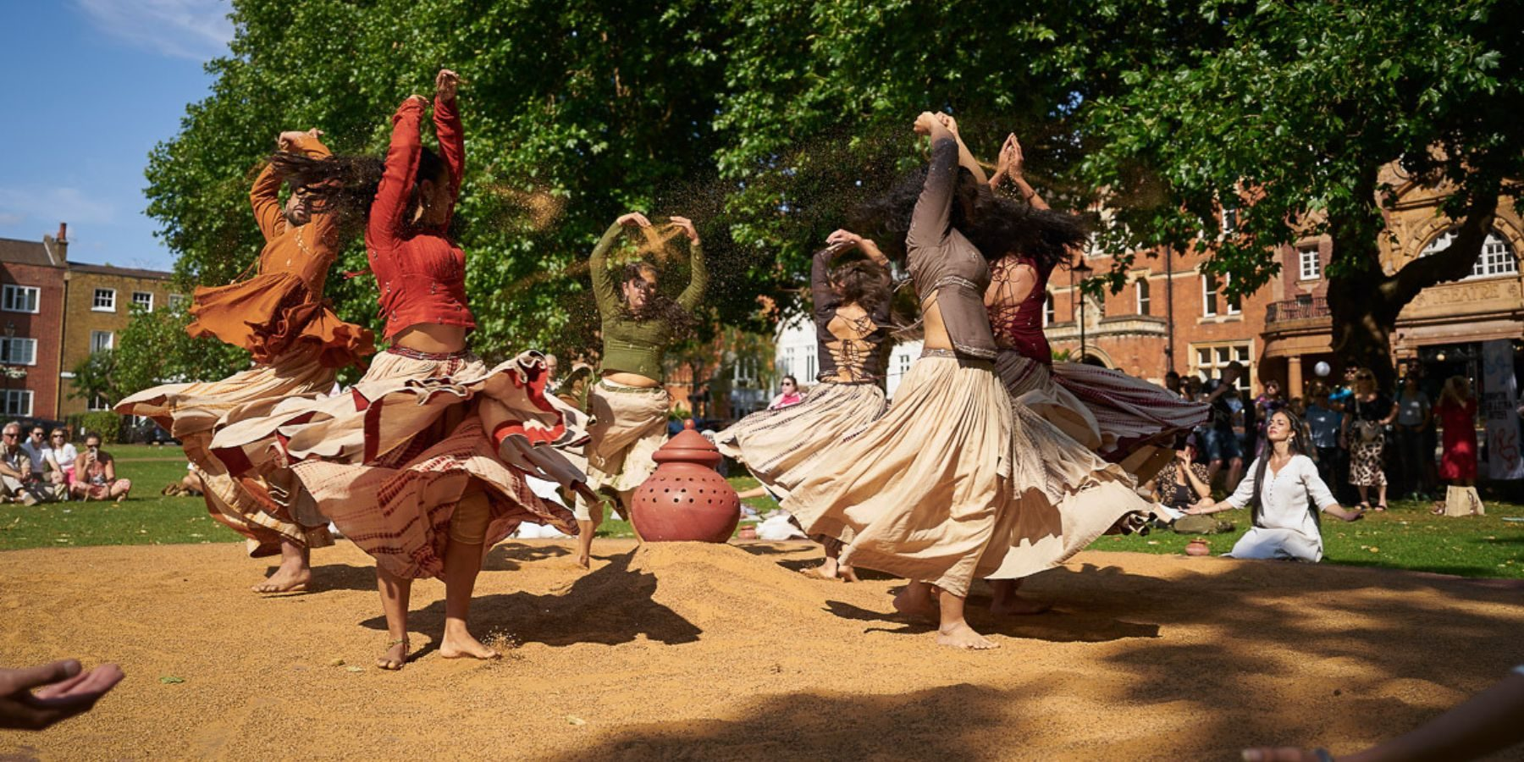

Saturday 29th – Monday 31st August

Time   | 12-12.40pm  3-3.40pm  But you can come and go as you please.
Who is it for?   | 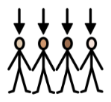  Everyone!
Where is it?   | 1000 Trades Square  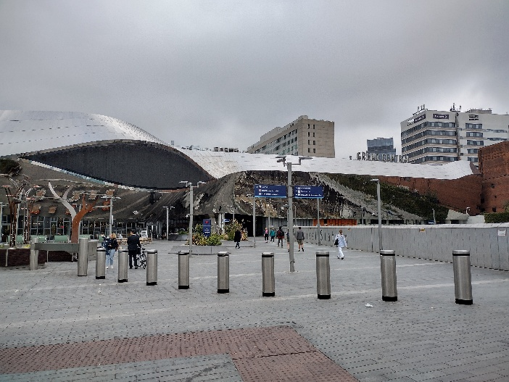
Access   | Touch Tour:  Saturday 29th – Monday 31st August  2.30-2.50pm  Audio Description:  Saturday 29th – Monday 31st August  12-12.40pm  2.30-3.40pm (2.30-2.50pm Touch Tour, 3-3.40pm Performance)  Relaxed Sensory Session in the Access Hub (indoors, near East entrance to Bullring):  Saturday 29th – Monday 31st August  2.45-4.15pm  There is a signposted Accessible Viewpoint near the performance space.  There is an Access & Information Point at 1000 Trades Square.    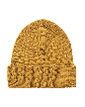    There will be Access Hosts nearby in yellow t-shirts and yellow hats to support you.  There is no written text.  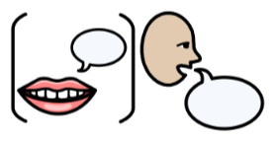There is speech.
Content warnings   | It may be loud.  There may be crowds.
Main themes   | 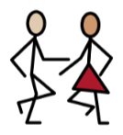  Dance    Music    Celebration    Gujarati Folk Dance

What will happen during the activity?

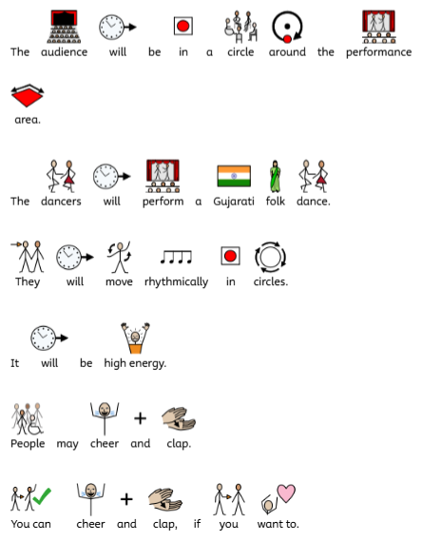

Find out more
https://withoutwalls.uk.com/programme/garbh-2/

https://www.birminghamhippodrome.com/calendar/garbh/

Contact us
charlotteboyer@briminghamhippodrome.com
aadildin@birminghamhippodrome.com

