Mirror Bull City

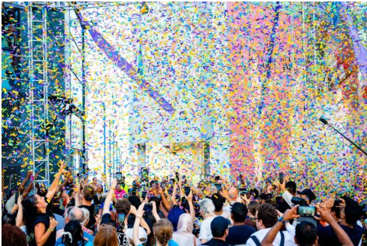

Saturday 29th – Monday 31st August

Time  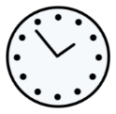 | 12-6pm each day.  But you can come and go as you please.
Who is it for?   | 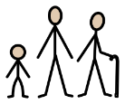  All ages.
Where is it?  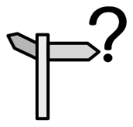 | Rotunda Square  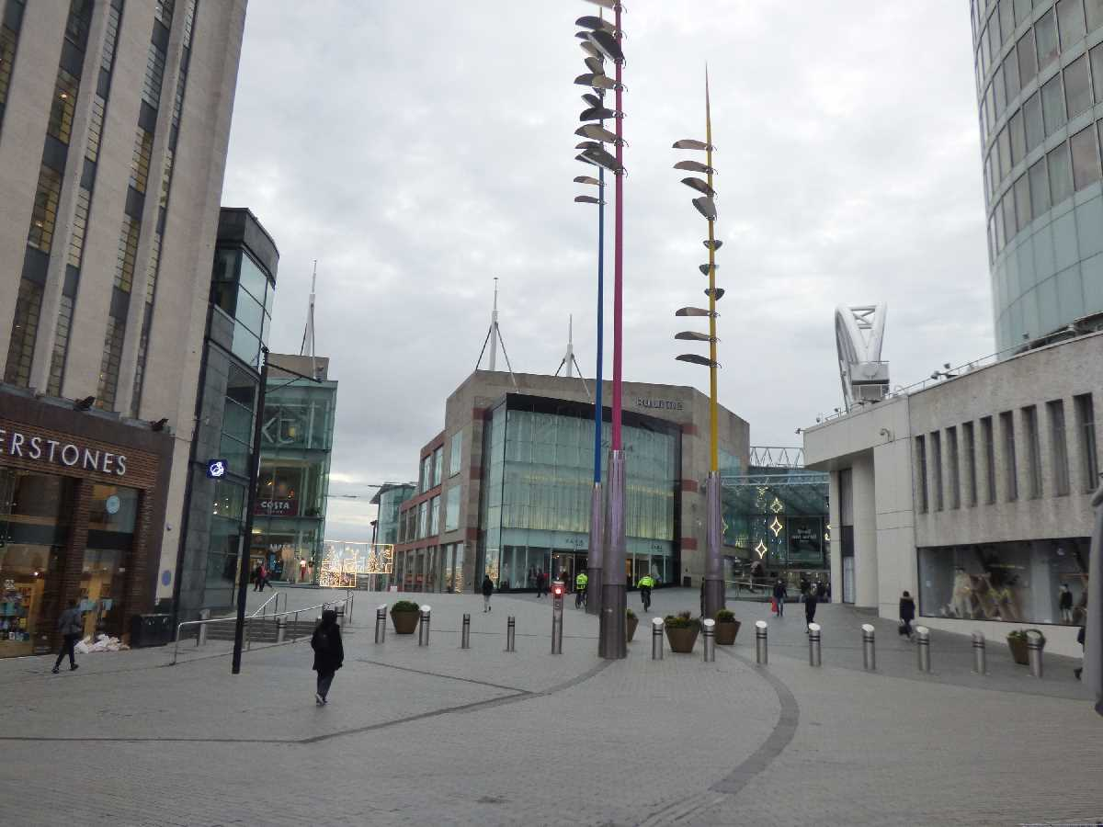
Access  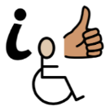 | Relaxed Sensory Sessions in the Access Hub (inside, near the East entrance to the Bullring):  Saturday 29th – Monday 31st August  4.30-6pm    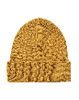    There will be Access Hosts nearby in yellow t-shirts and yellow hats to support you.
Content Warnings   |   The music might be loud.  It may be very bright and flashy.  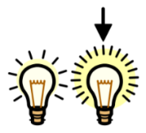  You can get colour therapy glasses, ear defenders, and ear plugs from the Accessible Viewpoint or the Access Hub.      It may be very busy and crowds may form.  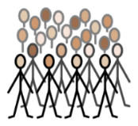

What will happen during the performance?

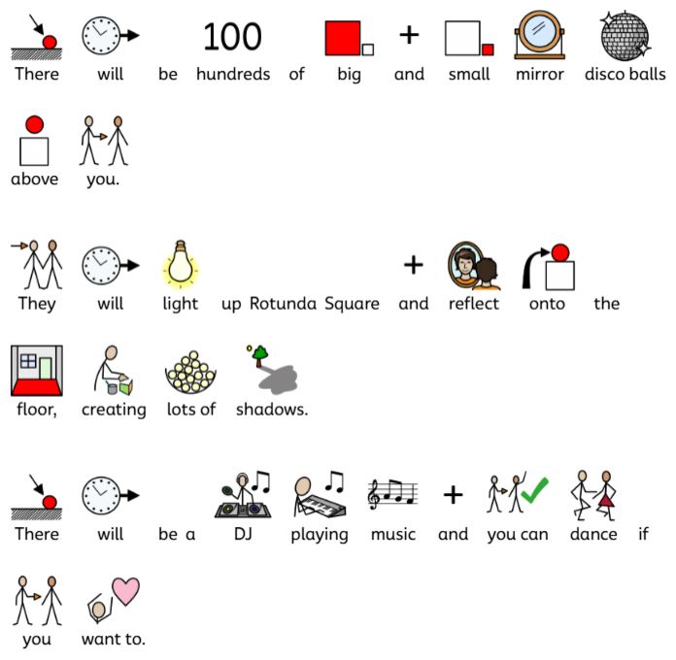

Find out more
Saturday event page - https://www.birminghamhippodrome.com/calendar/mirror-bull-city-always-k-pop-takeover-with-dj-emkay/

Sunday event page - https://www.birminghamhippodrome.com/calendar/mirror-bull-city-the-night-owl-takeover/

Monday event page - https://www.birminghamhippodrome.com/calendar/mirror-bull-city-mostly-jazz-funk-soul-takeover-with-huey-morgan-dj-set/

Contact us
charlotteboyer@birminghamhippodrome.com
aadildin@birminghamhippodrome.com

