Propel Dance Takeover

by

Propel Dance

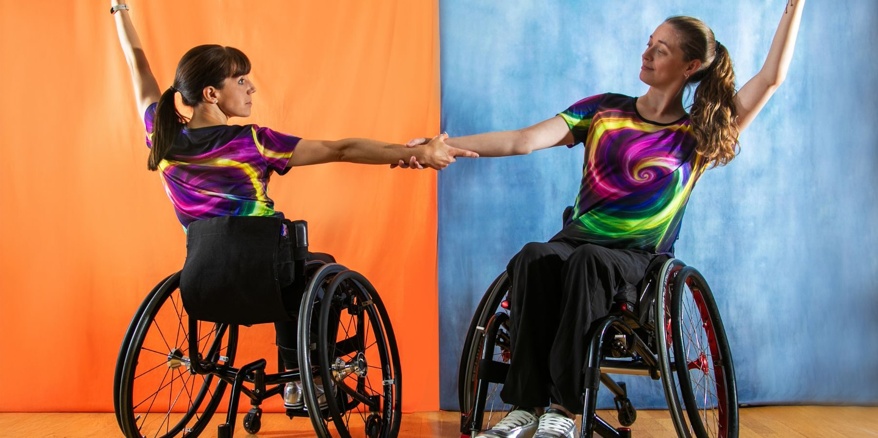

Saturday 29th August

Time   | 2.10-3.40pm  4.20-6pm  But you can come and go as you please.
Who is it for?   |   Everyone!  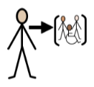  This is an inclusive event.
Where is it?   | Inside Bullring – Lower Mall West  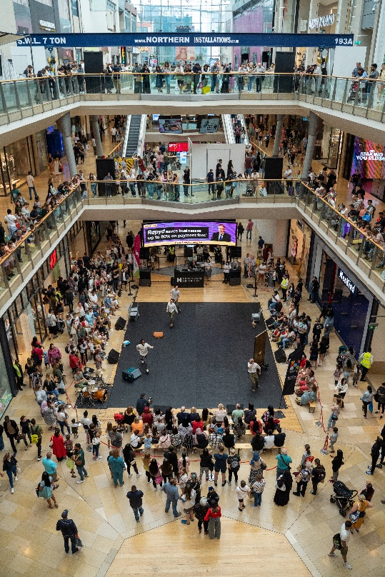
Access   | Audio Description:  Saturday 29th August  2.10-3.40pm  British Sign Language (BSL) Interpretation:  Saturday 29th August  4.20-6pm  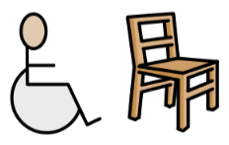  There are signposted Accessible Viewpoints on the ground floor of Bullring, and on the middle level outside HMV and Boots.  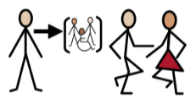  It is an inclusive dance activity.    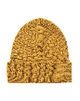    There will be Access Hosts nearby in yellow t-shirts and yellow hats to support you.
Content warnings   | It may be loud.  It is interactive.  There may be crowds.  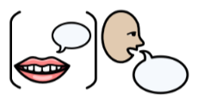There may be speech.
Main themes   | 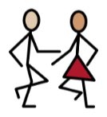  Dance    Inclusion    Workshop

What will happen during the activity?

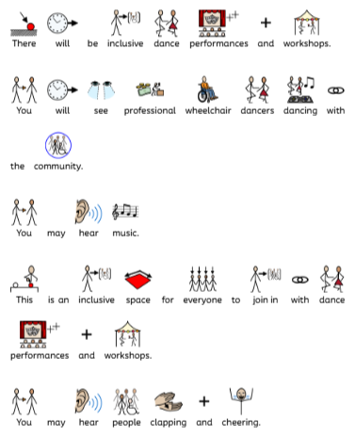

Find out more
https://propeldance.uk/

https://www.birminghamhippodrome.com/calendar/propel-dance-takeover/

Contact us
charlotteboyer@briminghamhippodrome.com
aadildin@birminghamhippodrome.com

